**Web Development Minor Project**

**July-2022 Batch**

**Kartik Deepu**

Please find the link for the entire project here:

<https://drive.google.com/drive/folders/1tWQgBjuomdbXaE3eE_aNfsOI4r0qiCMw?usp=sharing>

homepage.html is the starting point.

**Homepage:**

**On hovering over a country name, the country flag is displayed and on clicking it shows the historical places of that country.**

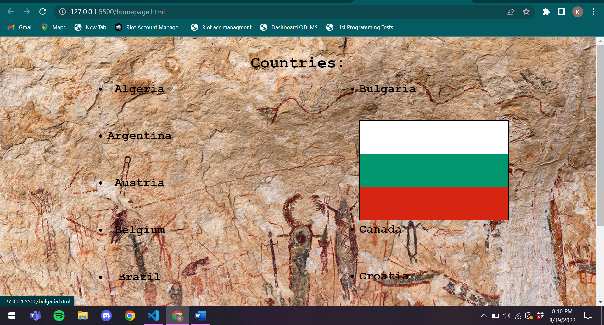

**Code:**

<!DOCTYPE html>

<html lang="en">

<head>

    <meta charset="UTF-8">

    <meta http-equiv="X-UA-Compatible" content="IE=edge">

    <meta name="viewport" content="width=device-width, initial-scale=1.0">

    <title>Homepage</title>

    <style>

        body{

            font-family: 'Courier New', Courier, monospace;

        }

        ul {

            display: table;

            margin: 0 auto;

        }

        li{

            margin-bottom: 50px;

            font-weight: bolder;

            font-size:x-large;

        }

        img{

        height:0;

        width:0;

        transition:height 0.3s, width 0.3s;

        border-color: black;

        border-width: 0px;

        border-style: solid;

        }

        li.alg:hover+ img, li.arg:hover + img,

        li.aus:hover + img, li.bel:hover + img,

        li.bra:hover + img, li.bul:hover + img,

        li.can:hover + img, li.cro:hover + img,

        li.cze:hover + img, li.ind:hover + img

        {

            height: 200px;

            width:300px;

            border-width: 1px;

        }

        a{

            color:  black;

            text-decoration: none

        }

    </style>

</head>

<body  background="background.jpg">

    <div style="width:100%; height:1vh;">

    </div>

    <h1 align="center">

        Countries:

    </h1>

    <div style="grid-template-columns:auto auto; display: grid;">

        <div>

            <ul align="center">

                <li class="alg"><a href="algeria.html" target="_blank">Algeria</a></li>

                <img src="algeria.png">

                <li class="arg"><a href="argentina.html" target="_blank">Argentina</a></li>

                <img src="argentina.png">

                <li class="aus"><a href="austria.html" target="_blank">Austria</a></li>

                <img src="austria.png">

                <li class="bel"><a href="belgium.html" target="_blank">Belgium</a></li>

                <img src="belgium.png">

                <li class="bra"><a href="brazil.html" target="_blank">Brazil</a></li>

                <img src="brazil.png">

            </ul>

        </div>

        <div>

            <ul>

                <li class="bul"><a href="bulgaria.html" target="_blank">Bulgaria</a></li>

                <img src="bulgaria.png">

                <li class="can"><a href="canada.html" target="_blank">Canada</a></li>

                <img src="canada.png">

                <li class="cro"><a href="croatia.html" target="_blank">Croatia</a></li>

                <img src="croatia.png">

                <li class="cze"><a href="czech.html" target="_blank">Czech Republic</a></li>

                <img src="czech.png">

                <li class="ind"><a href="india.html" target="_blank">India</a></li>

                <img src="india.png">

            </ul>

        </div>

    </div>

</body>

</html>

**WebPage for Algeria:**

**Images of a certain historical place cycle in an infinite loop, between 3 images as shown below. This is applicable to all images of all historical places in all countries.**

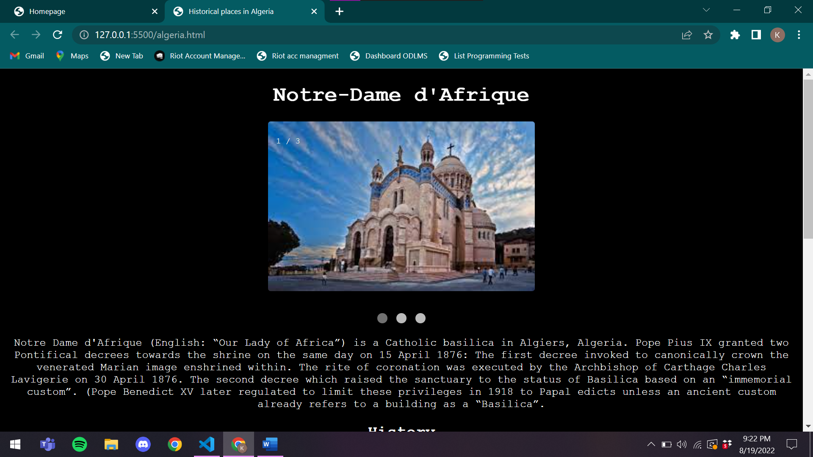

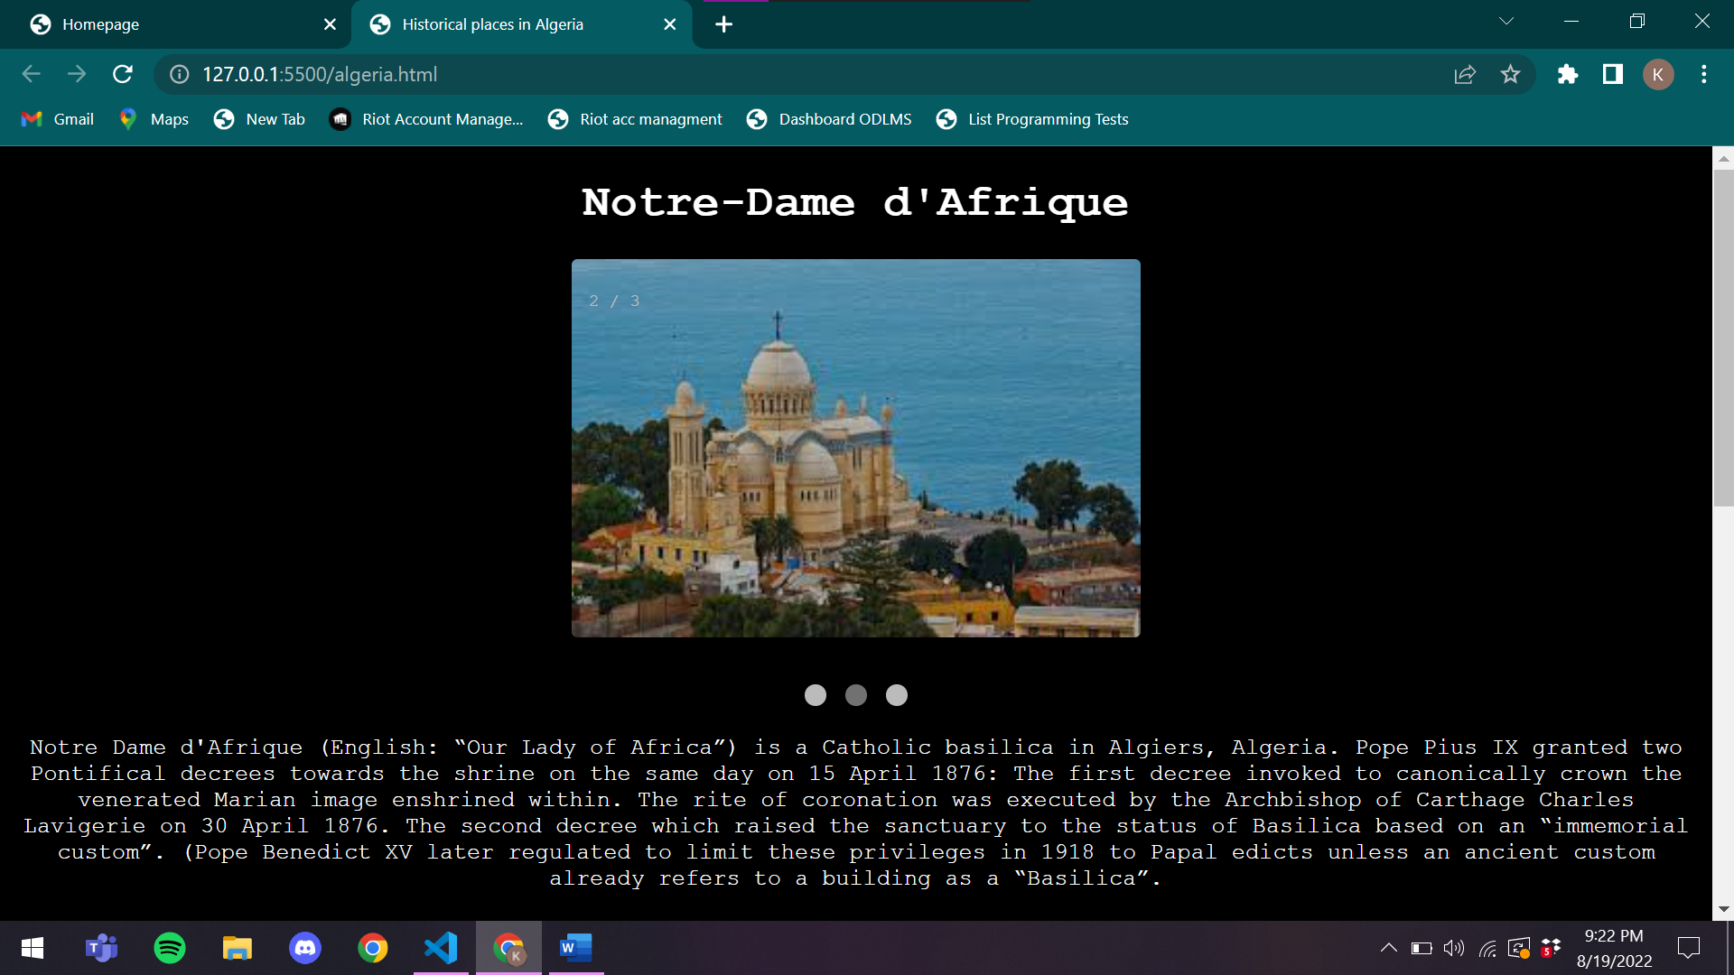

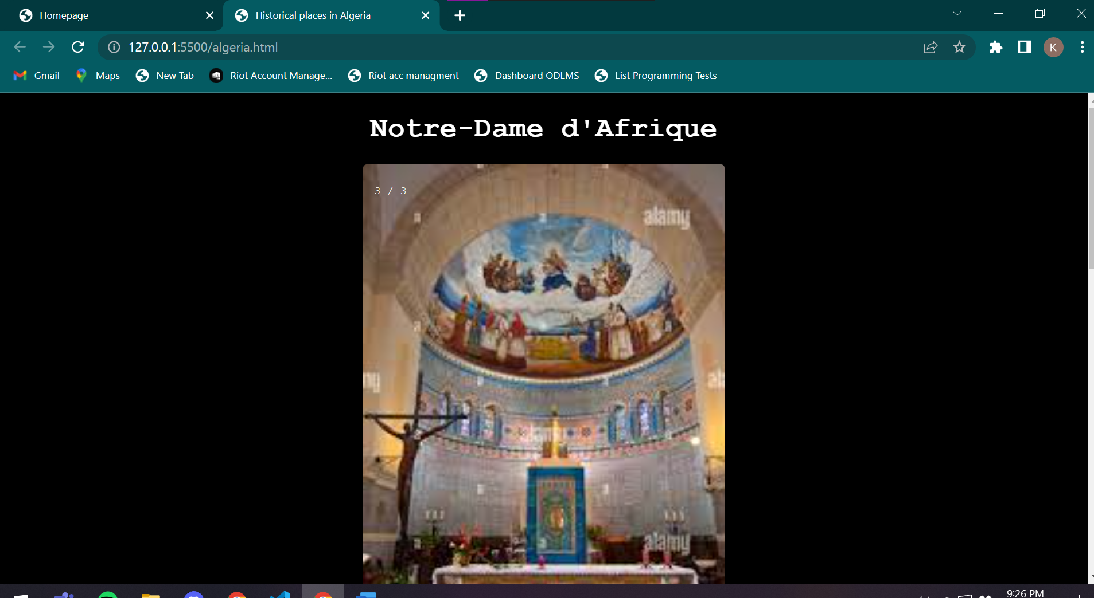

**Code:**

<!DOCTYPE html>

<html lang="en">

<head>

    <meta charset="UTF-8">

    <meta http-equiv="X-UA-Compatible" content="IE=edge">

    <meta name="viewport" content="width=device-width, initial-scale=1.0">

    <title>Historical places in Algeria</title>

    <style>

        body{

            font-family: 'Courier New', Courier, monospace;

            text-align: center;

            color: white;

            background-color: black;

        }

        img{

            border-radius: 4px;

        }

        div{

            margin-top: 15px;

        }

        * {box-sizing: border-box;}

        .mySlides {display: none;}

        img {vertical-align: middle;}

        .slideshow-container {

            max-width: 400px;

            position: relative;

            margin: auto;

        }

        .text {

        color: #f2f2f2;

        font-size: 15px;

        padding: 8px 12px;

        position: absolute;

        bottom: 8px;

        width: 100%;

        text-align: center;

        }

        .numbertext {

        color: #f2f2f2;

        font-size: 12px;

        padding: 8px 12px;

        position: absolute;

        top: 0;

        }

        .dot {

        height: 15px;

        width: 15px;

        margin: 0 2px;

        background-color: #bbb;

        border-radius: 50%;

        display: inline-block;

        transition: background-color 0.6s ease;

        }

        .active {

        background-color: #717171;

        }

        .fade {

        animation-name: fade;

        animation-duration: 1.5s;

        }

        @keyframes fade {

        from {opacity: .4}

        to {opacity: 1}

        }

        @media only screen and (max-width: 300px) {

        .text {font-size: 11px}

        }

    </style>

</head>

<body>

    <h1>Notre-Dame d'Afrique</h1>

  <div class="slideshow-container">

    <div class="mySlides fade">

      <div class="numbertext">1 / 3</div>

      <img src="/Algeria/algeria1.jpeg" style="width:100%">

    </div>

    <div class="mySlides fade">

      <div class="numbertext">2 / 3</div>

      <img src="/Algeria/algeria2.jpeg" style="width:100%">

    </div>

    <div class="mySlides fade">

      <div class="numbertext">3 / 3</div>

      <img src="Algeria/algeria3.jpeg" style="width:100%">

    </div>

    </div>

    <br>

    <div style="text-align:center">

      <span class="dot"></span>

      <span class="dot"></span>

      <span class="dot"></span>

    </div>

    <div>

        Notre Dame d'Afrique (English: “Our Lady of Africa”) is a Catholic basilica in Algiers, Algeria.

        Pope Pius IX granted two Pontifical decrees towards the shrine on the same day on 15 April 1876:

        The first decree invoked to canonically crown the venerated Marian image enshrined within. The rite of coronation was executed by the Archbishop of Carthage Charles Lavigerie on 30 April 1876.

        The second decree which raised the sanctuary to the status of Basilica based on an “immemorial custom”. (Pope Benedict XV later regulated to limit these privileges in 1918 to Papal edicts unless an ancient custom already refers to a building as a “Basilica”.

    </div>

    <h2>History</h2>

    <div>

        It was Louis-Antoine-Augustin Pavy, who served as the Bishop of Algiers from 1846 to 1866, who paved the way for its construction.[1] The basilica was inaugurated in 1872, after fourteen years of construction. It was founded by Charles Lavigerie.[2] Its architect, Jean-Eugène Fromageau, who had been appointed the chief architect for ecclesiastical buildings in French Algeria in 1859, employed a Neo-Byzantine style.[3] Its floor plan is unusual as the choir is situated on the southeast instead of the usual east side of the building.

        The basilica contains 46 stained glass windows installed in the 19th century. They were blown out during a bombing of the area in April 1943 and have been restored twice since the end of World War II.[4]

        In 1930 an organ, built in 1911, was donated to the basilica by the wife of the late Albert Weddell, a wealthy English resident in Algiers at Villa Georges and friend of the French composer Camille Saint-Saëns who had inaugurated the organ at Weddell's home.

        The basilica was damaged by the 2003 Boumerdès earthquake. A reconstruction project was initiated by Archbishop Henri Teissier in 2003, but work on the project did not start until the spring of 2007. The total cost of restoration was 5.1 million euros. The project took three years to complete.[4]

    </div>

    <h1>Royal Mausoleum of Mauretania</h1>

    <div class="slideshow-container">

        <div class="mySlides fade">

          <div class="numbertext">1 / 3</div>

          <img src="Algeria/algeria4.jpeg" style="width:100%">

        </div>

        <div class="mySlides fade">

          <div class="numbertext">2 / 3</div>

          <img src="Algeria/algeria5.jpeg" style="width:100%">

        </div>

        <div class="mySlides fade">

          <div class="numbertext">3 / 3</div>

          <img src="Algeria/algeria6.jpeg" style="width:100%">

        </div>

        </div>

        <br>

        <div style="text-align:center">

          <span class="dot"></span>

          <span class="dot"></span>

          <span class="dot"></span>

        </div>

    <div>

        The Royal Mausoleum of Mauretania is a funerary monument located on the road between Cherchell and Algiers, in Tipaza Province, Algeria. The mausoleum is the tomb where the Numidian Berber King Juba II (son of Juba I of Numidia) and the Queen Cleopatra Selene II, sovereigns of Numidia and Mauretania Caesariensis, were allegedly buried. However, their human remains have not been found at the site, perhaps due to tomb raiding.

    </div>

    <h2>History</h2>

    <div>

        The sepulchre is sometimes known as the Mausoleum of Juba II and Cleopatra Selene. In French, it is called the Tombeau de la Chrétienne ("the tomb of the Christian woman") because there is a Christian cross-like shape of the division lines on the false door.[citation needed] In Arabic, the mausoleum is called the Kubr-er-Rumia or Kbor er Roumia, which means "tomb of the Christian woman", as Rûm was taken in Arabic as the Eastern Roman Empire and, in North Africa, rumi took the meaning "Christian".[2] It may have been a deformation of a Punic phrase for "the royal tomb".

    </div>

    <script>

        let slideIndex = 0;

        showSlides();

        function showSlides() {

          let i;

          let slides = document.getElementsByClassName("mySlides");

          let dots = document.getElementsByClassName("dot");

          for (i = 0; i < slides.length; i++) {

            slides[i].style.display = "none";

          }

          slideIndex++;

          if (slideIndex > slides.length) {slideIndex = 1}

          for (i = 0; i < dots.length; i++) {

            dots[i].className = dots[i].className.replace(" active", "");

          }

          slides[slideIndex-1].style.display = "block";

          dots[slideIndex-1].className += " active";

          setTimeout(showSlides, 2000); // Change image every 2 seconds

        }

    </script>

</body>

</html>

**WebPage for Argentina:**

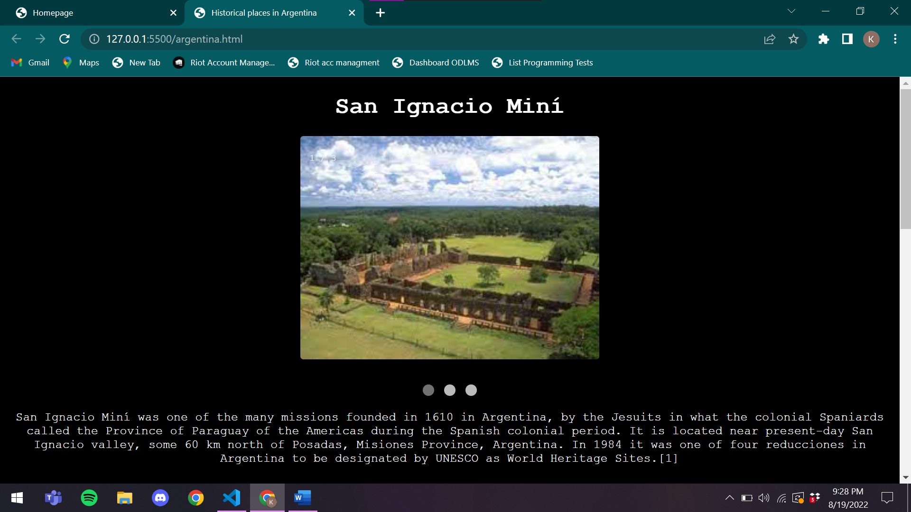

**Code:**

<!DOCTYPE html>

<html lang="en">

<head>

    <meta charset="UTF-8">

    <meta http-equiv="X-UA-Compatible" content="IE=edge">

    <meta name="viewport" content="width=device-width, initial-scale=1.0">

    <title>Historical places in Argentina</title>

    <style>

        body{

            font-family: 'Courier New', Courier, monospace;

            text-align: center;

            color: white;

            background-color: black;

        }

        img{

            border-radius: 4px;

        }

        div{

            margin-top: 15px;

        }

        * {box-sizing: border-box;}

        .mySlides {display: none;}

        img {vertical-align: middle;}

        .slideshow-container {

            max-width: 400px;

            position: relative;

            margin: auto;

        }

        .text {

        color: #f2f2f2;

        font-size: 15px;

        padding: 8px 12px;

        position: absolute;

        bottom: 8px;

        width: 100%;

        text-align: center;

        }

        .numbertext {

        color: #f2f2f2;

        font-size: 12px;

        padding: 8px 12px;

        position: absolute;

        top: 0;

        }

        .dot {

        height: 15px;

        width: 15px;

        margin: 0 2px;

        background-color: #bbb;

        border-radius: 50%;

        display: inline-block;

        transition: background-color 0.6s ease;

        }

        .active {

        background-color: #717171;

        }

        .fade {

        animation-name: fade;

        animation-duration: 1.5s;

        }

        @keyframes fade {

        from {opacity: .4}

        to {opacity: 1}

        }

        @media only screen and (max-width: 300px) {

        .text {font-size: 11px}

        }

    </style>

</head>

<body>

    <h1>San Ignacio Miní</h1>

    <div class="slideshow-container">

        <div class="mySlides fade">

          <div class="numbertext">1 / 3</div>

          <img src="/Argentina/arg2.jpeg" style="width:100%">

        </div>

        <div class="mySlides fade">

          <div class="numbertext">2 / 3</div>

          <img src="/Argentina/arg1.jpeg" style="width:100%">

        </div>

        <div class="mySlides fade">

          <div class="numbertext">3 / 3</div>

          <img src="/Argentina/arg3.jpeg" style="width:100%">

        </div>

        </div>

        <br>

        <div style="text-align:center">

          <span class="dot"></span>

          <span class="dot"></span>

          <span class="dot"></span>

        </div>

    <div>

        San Ignacio Miní was one of the many missions founded in 1610 in Argentina, by the Jesuits in what the colonial Spaniards called the Province of Paraguay of the Americas during the Spanish colonial period. It is located near present-day San Ignacio valley, some 60 km north of Posadas, Misiones Province, Argentina. In 1984 it was one of four reducciones in Argentina to be designated by UNESCO as World Heritage Sites.[1]

    </div>

    <h2>History</h2>

    <div>

        The original mission was erected near the year 1610 by Jesuit priests José Cataldino and Simón Maceta in the region called Guayrá by the natives and La Pinería by the Spanish conquistadores in present Paraná State, Brazil. Because of the constant attacks of the Bandeirantes, the mission moved in 1632, and did not settle in its current location until 1696. It was called San Ignacio Miní (minor in Guaraní) to distinguish it from the larger mission, San Ignacio Guazú (great), in Paraguay.

        In the 18th century, the mission had a population of around 3000 people, mostly indigenous peoples. They produced rich cultural and handicraft products, which the Spanish commercialized by trade via the nearby Paraná River. After the Suppression of the Society of Jesus in 1767, the Jesuits left the mission a year later. Luso-Brazilian forces destroyed the mission in 1817, as well as other missions in the area, in the war against the independent movement in the Banda Oriental.[2]

        San Ignacio Mini The ruins are one of the best preserved among the several built in the territory of the Province of Paraguay, which today is divided among Argentina, Brazil and Paraguay. Due to its accessibility, it is one of the most visited. Overgrown by dense vegetation, the remains of the mission, built in the "Guaraní baroque" style, were found in 1897. It attracted greater popular interest after the 1903 expedition to the site by poet Leopoldo Lugones. The government did not undertake formal exploration and restoration until 1940.

        Originally the main square was bounded by the church, a cabildo, a cemetery, a monastery and some houses. The magnificent church with 74 metres length and 24 metres width was designed by Italian priest Juan Brasanelli, and build using the local red sandstone. The width of the walls are around 2 metres, what in spite of the fragile material let the constructions remain standing after over two centuries.

        In 1984 the ruins were declared as a World Heritage Site by UNESCO. The site is the location of the Museo Jesuítico de San Ignacio Miní museum, constructed after the international recognition. Other Jesuit missions' sites in the Misiones Province designated as World Heritage Sites the same year include Reducción de Santa Ana, Santa María La Mayor, and Nuestra Señora de Loreto.[3]

        San Ignacio Miní was included in the inaugural 1996 World Monuments Watch by the World Monuments Fund, drawing attention to the urgency of needed repairs and a full preservation plan.[4] With funding from American Express,[5] the lateral (eastern) portal was restored. Since then, the main portal of the mission has also been restored, and an interpretation center has been constructed. An international conference on the future of the site has taken place.

    </div>

    <h1>La Recoleta Cemetery</h1>

    <div class="slideshow-container">

        <div class="mySlides fade">

          <div class="numbertext">1 / 3</div>

          <img src="/Argentina/arg4.jpeg" style="width:100%">

        </div>

        <div class="mySlides fade">

          <div class="numbertext">2 / 3</div>

          <img src="/Argentina/arg5.jpeg" style="width:100%">

        </div>

        <div class="mySlides fade">

          <div class="numbertext">3 / 3</div>

          <img src="/Argentina/arg6.jpeg" style="width:100%">

        </div>

        </div>

        <br>

        <div style="text-align:center">

          <span class="dot"></span>

          <span class="dot"></span>

          <span class="dot"></span>

        </div>

    <div>

        La Recoleta Cemetery (Spanish: Cementerio de la Recoleta) is a cemetery located in the Recoleta neighbourhood of Buenos Aires, Argentina. It contains the graves of notable people, including Eva Perón, presidents of Argentina, Nobel Prize winners, the founder of the Argentine Navy, and military commanders like Julio Argentino Roca. In 2011, the BBC hailed it as one of the world's best cemeteries,[5] and in 2013, CNN listed it among the 10 most beautiful cemeteries in the world.[6]

    </div>

    <h2>History</h2>

    <div>

        Franciscan Recollect monks (los recoletos)[7] arrived in this area, then the outskirts of Buenos Aires, in the early eighteenth century. The cemetery is built around the Recollect Convent (Convento de la Recoleta)[8] and a church, Our Lady of Pilar (Iglesia de Nuestra Señora del Pilar), built in 1732.

        The order was disbanded in 1822, and the garden of the convent was converted into the first public cemetery in Buenos Aires. Inaugurated on 17 November of the same year under the name of Cementerio del Norte (Northern Cemetery),[9] those responsible for its creation were the then-Governor Martin Rodríguez, who would be eventually buried in the cemetery, and government minister Bernardino Rivadavia.[2]

        The 1822 layout was done by French civil engineer Próspero Catelin, who also designed the current facade of the Buenos Aires Metropolitan Cathedral.[10] The cemetery was last remodeled in 1881, while Torcuato de Alvear was mayor of the city, by the Italian architect Juan Antonio Buschiazzo.[11]

    </div>

    <script>

        let slideIndex = 0;

        showSlides();

        function showSlides() {

          let i;

          let slides = document.getElementsByClassName("mySlides");

          let dots = document.getElementsByClassName("dot");

          for (i = 0; i < slides.length; i++) {

            slides[i].style.display = "none";

          }

          slideIndex++;

          if (slideIndex > slides.length) {slideIndex = 1}

          for (i = 0; i < dots.length; i++) {

            dots[i].className = dots[i].className.replace(" active", "");

          }

          slides[slideIndex-1].style.display = "block";

          dots[slideIndex-1].className += " active";

          setTimeout(showSlides, 2000); // Change image every 2 seconds

        }

    </script>

</body>

</html>

**WebPage for Austria:**

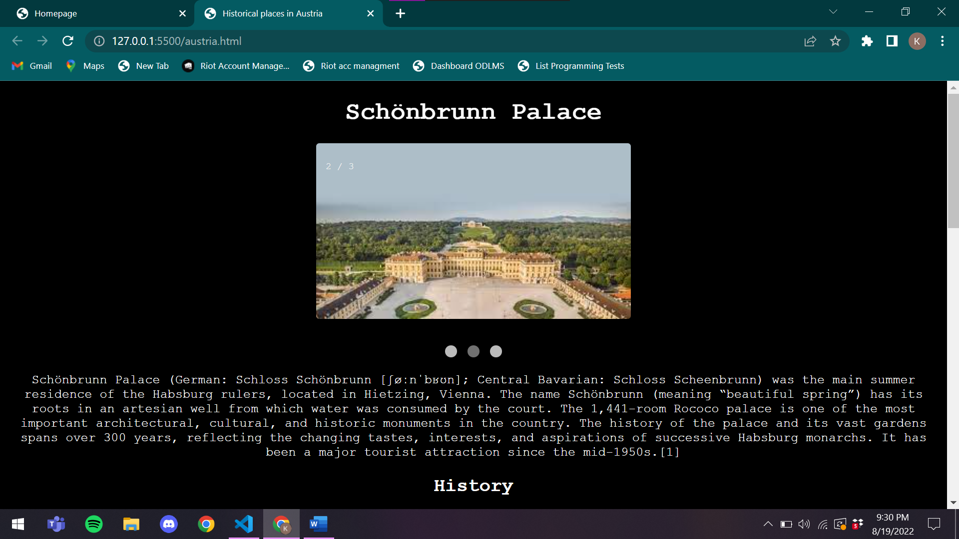

**Code:**

<!DOCTYPE html>

<html lang="en">

<head>

    <meta charset="UTF-8">

    <meta http-equiv="X-UA-Compatible" content="IE=edge">

    <meta name="viewport" content="width=device-width, initial-scale=1.0">

    <title>Historical places in Austria</title>

    <style>

        body{

            font-family: 'Courier New', Courier, monospace;

            text-align: center;

            color: white;

            background-color: black;

        }

        img{

            border-radius: 4px;

        }

        div{

            margin-top: 15px;

        }

        * {box-sizing: border-box;}

        .mySlides {display: none;}

        img {vertical-align: middle;}

        .slideshow-container {

            max-width: 400px;

            position: relative;

            margin: auto;

        }

        .text {

        color: #f2f2f2;

        font-size: 15px;

        padding: 8px 12px;

        position: absolute;

        bottom: 8px;

        width: 100%;

        text-align: center;

        }

        .numbertext {

        color: #f2f2f2;

        font-size: 12px;

        padding: 8px 12px;

        position: absolute;

        top: 0;

        }

        .dot {

        height: 15px;

        width: 15px;

        margin: 0 2px;

        background-color: #bbb;

        border-radius: 50%;

        display: inline-block;

        transition: background-color 0.6s ease;

        }

        .active {

        background-color: #717171;

        }

        .fade {

        animation-name: fade;

        animation-duration: 1.5s;

        }

        @keyframes fade {

        from {opacity: .4}

        to {opacity: 1}

        }

        @media only screen and (max-width: 300px) {

        .text {font-size: 11px}

        }

    </style>

</head>

<body>

    <h1>Schönbrunn Palace</h1>

    <div class="slideshow-container">

        <div class="mySlides fade">

          <div class="numbertext">1 / 3</div>

          <img src="/austria/aus1.jpeg" style="width:100%">

        </div>

        <div class="mySlides fade">

          <div class="numbertext">2 / 3</div>

          <img src="/austria/aus2.jpeg" style="width:100%">

        </div>

        <div class="mySlides fade">

          <div class="numbertext">3 / 3</div>

          <img src="/austria/aus3.jpeg" style="width:100%">

        </div>

        </div>

        <br>

        <div style="text-align:center">

          <span class="dot"></span>

          <span class="dot"></span>

          <span class="dot"></span>

        </div>

    <div>

        Schönbrunn Palace (German: Schloss Schönbrunn [ʃøːnˈbʁʊn]; Central Bavarian: Schloss Scheenbrunn) was the main summer residence of the Habsburg rulers, located in Hietzing, Vienna. The name Schönbrunn (meaning “beautiful spring”) has its roots in an artesian well from which water was consumed by the court.

        The 1,441-room Rococo palace is one of the most important architectural, cultural, and historic monuments in the country. The history of the palace and its vast gardens spans over 300 years, reflecting the changing tastes, interests, and aspirations of successive Habsburg monarchs. It has been a major tourist attraction since the mid-1950s.[1]

    </div>

    <h2>History</h2>

    <div>

        In 1569, Holy Roman Emperor Maximilian II purchased a large floodplain of the Wien river beneath a hill, situated between Meidling and Hietzing. The former owner, in 1548, had erected a mansion called Katterburg. The emperor ordered the area to be fenced and put game there such as pheasants, ducks, deer and boar, in order for it to serve as the court's recreational hunting ground. In a small separate part of the area, "exotic" birds such as turkeys and peafowl were kept. Fishponds were also built.

        Das kaiserliche Lustschloß Schönbrunn, Ehrenhofseite by Bernardo Bellotto, 1759-1760

        During the next century, the area was used as a hunting and recreation ground. Eleonora Gonzaga, who loved hunting, spent much time there and was bequeathed the area as her widow's residence after the death of her husband, Ferdinand II. From 1638 to 1643, she added a palace to the Katterburg mansion, while in 1642 came the first mention of the name “Schönbrunn” on an invoice. The origins of the Schönbrunn orangery seem to go back to Eleonora Gonzaga as well. The Schönbrunn Palace in its present form was built and remodelled during the 1740–50s during the reign of empress Maria Theresa[2] who received the estate as a wedding gift. Franz I commissioned the redecoration of the palace exterior in the neoclassical style as it appears today.

        Franz Joseph, the longest-reigning emperor of Austria, was born at Schönbrunn and spent a great deal of his life there. He died there, at the age of 86, on 21 November 1916. Following the downfall of the Habsburg monarchy in November 1918, the palace became the property of the newly founded Austrian Republic and was preserved as a museum.

        After World War II and during the Allied Occupation of Austria (1945—55), Schönbrunn Palace was requisitioned to provide office space for both the British Delegation to the Allied Commission for Austria, and for the headquarters for the small British Military Garrison present in Vienna. With the reestablishment of the Austrian republic in 1955, the palace once again became a museum. It is still sometimes used for important events such as the meeting between U.S. president John F. Kennedy and Soviet premier Nikita Khrushchev in 1961.

        Since 1992, the palace and gardens have been owned and administered by the Schloss Schönbrunn Kultur-und Betriebsges.m.b.H., a limited-liability company wholly owned by the Republic of Austria. The company conducts preservation and restoration of all palace properties without state subsidies.[3] UNESCO catalogued Schönbrunn Palace on the World Heritage List in 1996, together with its gardens, as a remarkable Baroque ensemble and example of synthesis of the arts (Gesamtkunstwerk).

    </div>

    <h1>Hofburg</h1>

    <div class="slideshow-container">

        <div class="mySlides fade">

          <div class="numbertext">1 / 3</div>

          <img src="/austria/aus4.jpeg" style="width:100%">

        </div>

        <div class="mySlides fade">

          <div class="numbertext">2 / 3</div>

          <img src="/austria/aus5.jpeg" style="width:100%">

        </div>

        <div class="mySlides fade">

          <div class="numbertext">3 / 3</div>

          <img src="/austria/aus6.jpeg" style="width:100%">

        </div>

        </div>

        <br>

        <div style="text-align:center">

          <span class="dot"></span>

          <span class="dot"></span>

          <span class="dot"></span>

        </div>

    <div>

        The Hofburg is the former principal imperial palace of the Habsburg dynasty. Located in the centre of Vienna, it was built in the 13th century and expanded several times afterwards. It also served as the imperial winter residence, as Schönbrunn Palace was the summer residence. Since 1946 it is the official residence and workplace of the president of Austria.

        Since 1279 the Hofburg area has been the documented seat of government.[1] The Hofburg has been expanded over the centuries to include various residences (with the Amalienburg and the Albertina), the imperial chapel (Hofkapelle or Burgkapelle), the imperial library (Hofbibliothek), the treasury (Schatzkammer), the Burgtheater, the Spanish Riding School (Hofreitschule), the imperial mews (Stallburg and Hofstallungen).

        The palace faces the Heldenplatz (Heroes Square) ordered under the reign of Emperor Franz Joseph I, as part of what was planned to become the Kaiserforum [de] but which was never completed.

        Numerous architects have executed work at the Hofburg as it expanded, notably the Italian architect-engineer Filiberto Luchese, Lodovico Burnacini and Martino and Domenico Carlone, the Baroque architects Lukas von Hildebrandt and Joseph Emanuel Fischer von Erlach, Johann Fischer von Erlach, and the architects of the Neue Burg built between 1881 and 1913.

    </div>

    <h2>History</h2>

    <div>

        The name translates as "Castle of the Court", which denotes its origins when initially constructed during the Middle Ages. Initially planned in the 13th century as the seat of the Dukes of Austria, the palace expanded over the centuries, as they became increasingly powerful. From 1438 to 1583, and again from 1612 to 1806, it was the seat of the Habsburg kings and emperors of the Holy Roman Empire, and thereafter until 1918 the seat of the Emperors of Austria. Since then the palace has continued in its role as the seat of the head of state and is today used by the Austrian Federal President.

        It is also the permanent home of the Organization for Security and Co-operation in Europe (OSCE).

        The whole palace complex is under the administration of the governor (Burghauptmann), who in turn is part of the Burghauptmannschaft, an office which has been in existence since the Middle Ages under the auspices of the Burgrave. At present the Burghauptmannschaft is under the jurisdiction of the Federal Ministry of the Economy.

        In September 1958, parts of the Hofburg were opened to the public as a convention centre. In the first ten years, the Burghauptmannschaft operated the convention centre; since 1969 a private company (Hofburg Vienna – Wiener Kongresszentrum Hofburg Betriebsgesellschaft) has been managing the international congress and events centre. Every year the convention centre hosts about 300 to 350 events, with around 300,000 to 320,000 guests. Among the events are conventions and meetings as well as banquets, trade fairs, concerts, and balls

    </div>

    <script>

        let slideIndex = 0;

        showSlides();

        function showSlides() {

          let i;

          let slides = document.getElementsByClassName("mySlides");

          let dots = document.getElementsByClassName("dot");

          for (i = 0; i < slides.length; i++) {

            slides[i].style.display = "none";

          }

          slideIndex++;

          if (slideIndex > slides.length) {slideIndex = 1}

          for (i = 0; i < dots.length; i++) {

            dots[i].className = dots[i].className.replace(" active", "");

          }

          slides[slideIndex-1].style.display = "block";

          dots[slideIndex-1].className += " active";

          setTimeout(showSlides, 2000); // Change image every 2 seconds

        }

    </script>

</body>

</html>

**Webpage for Belgium:**

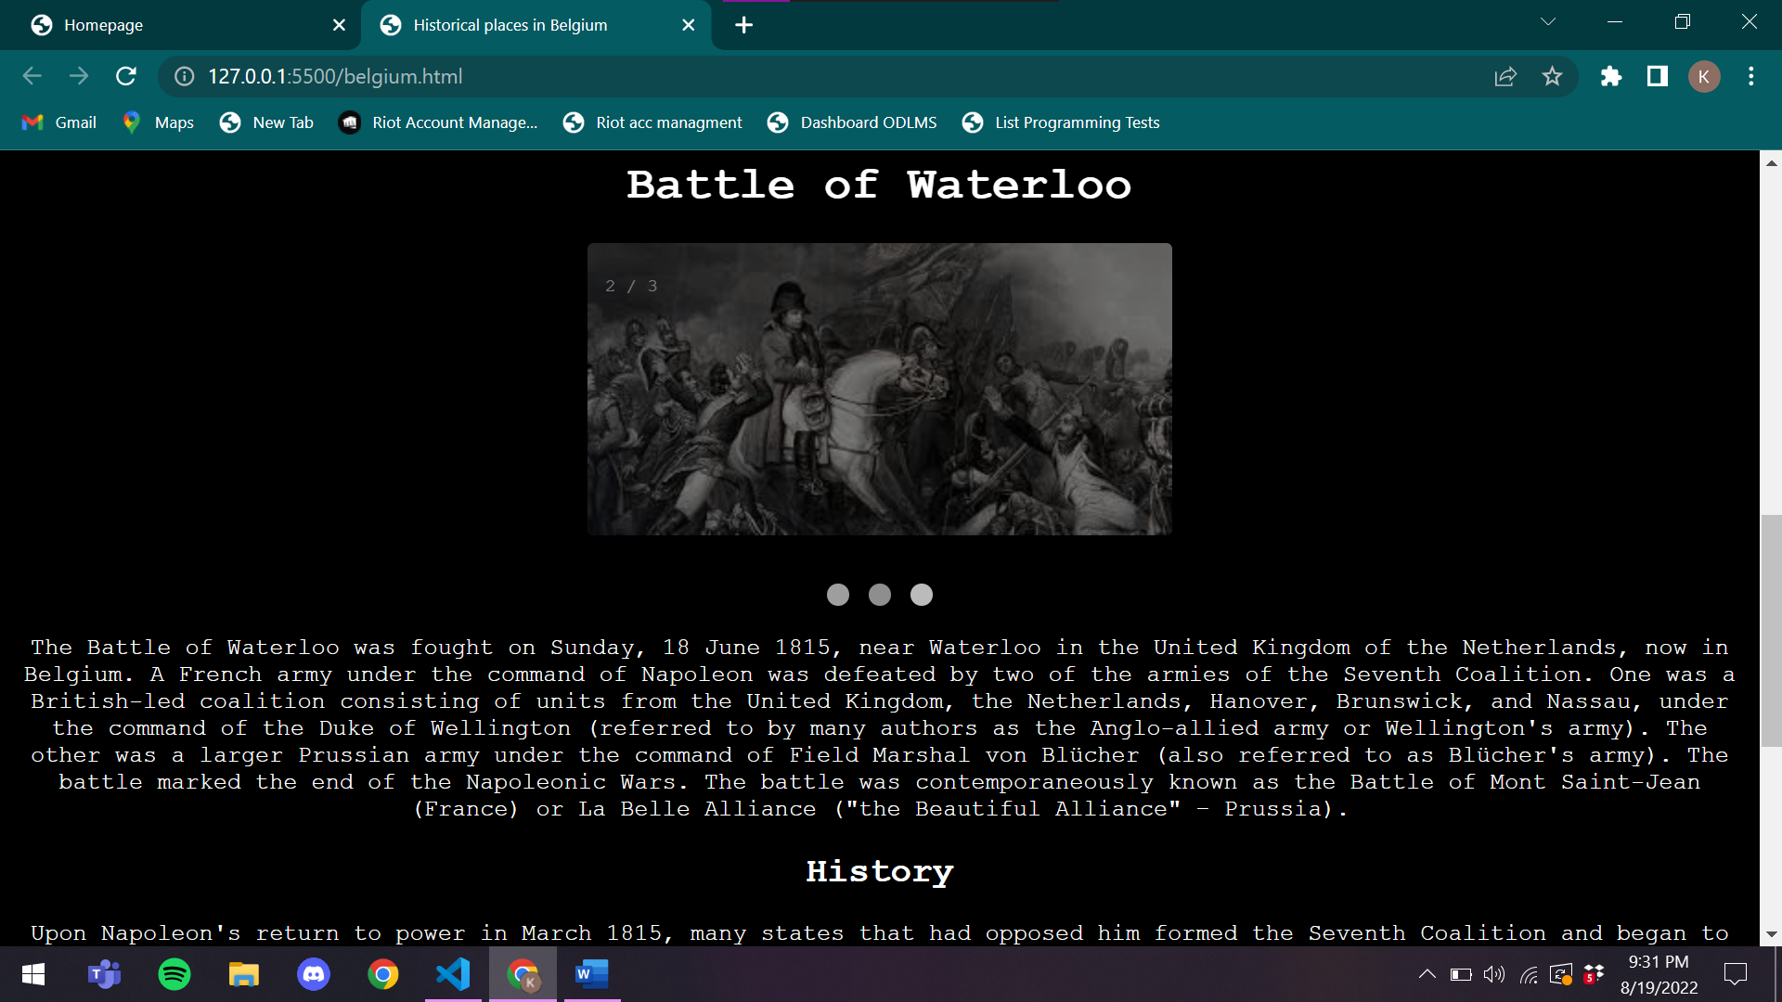

**Code:**

<!DOCTYPE html>

<html lang="en">

<head>

    <meta charset="UTF-8">

    <meta http-equiv="X-UA-Compatible" content="IE=edge">

    <meta name="viewport" content="width=device-width, initial-scale=1.0">

    <title>Historical places in Belgium</title>

    <style>

        body{

            font-family: 'Courier New', Courier, monospace;

            text-align: center;

            color: white;

            background-color: black;

        }

        img{

            border-radius: 4px;

        }

        div{

            margin-top: 15px;

        }

        * {box-sizing: border-box;}

        .mySlides {display: none;}

        img {vertical-align: middle;}

        .slideshow-container {

            max-width: 400px;

            position: relative;

            margin: auto;

        }

        .text {

        color: #f2f2f2;

        font-size: 15px;

        padding: 8px 12px;

        position: absolute;

        bottom: 8px;

        width: 100%;

        text-align: center;

        }

        .numbertext {

        color: #f2f2f2;

        font-size: 12px;

        padding: 8px 12px;

        position: absolute;

        top: 0;

        }

        .dot {

        height: 15px;

        width: 15px;

        margin: 0 2px;

        background-color: #bbb;

        border-radius: 50%;

        display: inline-block;

        transition: background-color 0.6s ease;

        }

        .active {

        background-color: #717171;

        }

        .fade {

        animation-name: fade;

        animation-duration: 1.5s;

        }

        @keyframes fade {

        from {opacity: .4}

        to {opacity: 1}

        }

        @media only screen and (max-width: 300px) {

        .text {font-size: 11px}

        }

    </style>

</head>

<body>

    <h1>Menin Gate</h1>

    <div class="slideshow-container">

        <div class="mySlides fade">

          <div class="numbertext">1 / 3</div>

          <img src="/belgium/bel1.jpeg" style="width:100%">

        </div>

        <div class="mySlides fade">

          <div class="numbertext">2 / 3</div>

          <img src="/belgium/bel2.jpeg" style="width:100%">

        </div>

        <div class="mySlides fade">

          <div class="numbertext">3 / 3</div>

          <img src="/belgium/bel3.jpeg" style="width:100%">

        </div>

        </div>

        <br>

        <div style="text-align:center">

          <span class="dot"></span>

          <span class="dot"></span>

          <span class="dot"></span>

        </div>

    <div>

        The Menin Gate Memorial to the Missing is a war memorial in Ypres, Belgium, dedicated to the British and Commonwealth soldiers who were killed in the Ypres Salient of World War I and whose graves are unknown. The memorial is located at the eastern exit of the town and marks the starting point for one of the main roads out of the town that led Allied soldiers to the front line. “Menin” is the traditional name of the gate in this location of Ypres' city walls because it leads to the town of Menen. Designed by Sir Reginald Blomfield and built by the Imperial War Graves Commission (since renamed the Commonwealth War Graves Commission), the Menin Gate Memorial was unveiled on 24 July 1927

    </div>

    <h2>History</h2>

    <div>

        In medieval times, the original narrow gateway on the eastern wall of Ypres was called the Hangoartpoort, "poort" being the Dutch word for gate. During the 17th and 18th centuries, while under the occupation of the Habsburgs and the French, the city was increasingly fortified. Major works were completed at the end of the 17th century by the French military engineer Sebastien Le Prestre, Seigneur de Vauban. At the outbreak of the First World War in August 1914, the eastern exit simply cut through the remains of the ramparts and crossed a moat. The gateway was by this time known as the Menenpoort, or Menin Gate in English, because the road leading through the gateway led to the small town of Menen.

        Ypres occupied a strategic position during the First World War because it stood in the path of Germany's planned sweep across the rest of Belgium, as had been called for in the Schlieffen Plan. By October 1914, the much battered Belgian Army broke the dykes on the Yser River to the north of the City to keep the western tip of Belgium out of German hands. Ypres, being the centre of a road network, anchored one end of this defensive feature and was also essential for the Germans if they wanted to take the Channel Ports through which British support was flooding into France. For the Allies, Ypres was also important because it eventually became the last major Belgian town that was not under German control.

        The importance of the town is reflected in the five major battles that occurred around it during the war. During the First Battle of Ypres the Allies halted the German Army's advance to the east of the city. The German army eventually surrounded the city on three sides, bombarding it throughout much of the war. The Second Battle of Ypres marked a second German attempt to take the city in April 1915. The third battle is more commonly referred to as Passchendaele, but this 1917 battle was a complex five-month engagement. The fourth and fifth battles occurred during 1918.

        British and Commonwealth soldiers often passed through the Menenpoort on their way to the front lines with some 300,000 of them being killed in the Ypres Salient. 90,000 of these soldiers have no known graves.

        From September to November 1915, the British 177th Tunnelling Company built tunnelled dugouts in the city ramparts near the Menin Gate. These were the first British tunnelled dugouts in the Ypres Salient.[2]

        The carved limestone lions adorning the original gate were damaged by shellfire, and were donated to the Australian War Memorial by the Mayor of Ypres in 1936. They were restored in 1987, and currently reside at the entrance to that Memorial, so that all visitors to the Memorial pass between them.[3] Replicas of the original Menin gate lions now sit at the entrance of the original gate in Ypres, a gift by the Australian government in recognition of the 100th anniversary of Australians serving in Flanders during the First World War.

    </div>

    <h1>Battle of Waterloo</h1>

    <div class="slideshow-container">

        <div class="mySlides fade">

          <div class="numbertext">1 / 3</div>

          <img src="/belgium/bel4.jpeg" style="width:100%">

        </div>

        <div class="mySlides fade">

          <div class="numbertext">2 / 3</div>

          <img src="/belgium/bel5.jpeg" style="width:100%">

        </div>

        <div class="mySlides fade">

          <div class="numbertext">3 / 3</div>

          <img src="/belgium/bel6.jpeg" style="width:100%">

        </div>

        </div>

        <br>

        <div style="text-align:center">

          <span class="dot"></span>

          <span class="dot"></span>

          <span class="dot"></span>

        </div>

    <div>

        The Battle of Waterloo was fought on Sunday, 18 June 1815, near Waterloo in the United Kingdom of the Netherlands, now in Belgium. A French army under the command of Napoleon was defeated by two of the armies of the Seventh Coalition. One was a British-led coalition consisting of units from the United Kingdom, the Netherlands, Hanover, Brunswick, and Nassau, under the command of the Duke of Wellington (referred to by many authors as the Anglo-allied army or Wellington's army). The other was a larger Prussian army under the command of Field Marshal von Blücher (also referred to as Blücher's army). The battle marked the end of the Napoleonic Wars. The battle was contemporaneously known as the Battle of Mont Saint-Jean (France) or La Belle Alliance ("the Beautiful Alliance" – Prussia).

    </div>

    <h2>History</h2>

    <div>

        Upon Napoleon's return to power in March 1815, many states that had opposed him formed the Seventh Coalition and began to mobilise armies. Wellington and Blücher's armies were cantoned close to the northeastern border of France. Napoleon planned to attack them separately in the hope of destroying them before they could join in a coordinated invasion of France with other members of the coalition. On 16 June, Napoleon successfully attacked the bulk of the Prussian army at the Battle of Ligny with his main force, causing the Prussians to withdraw northwards on 17 June, but parallel to Wellington and in good order.

        Napoleon sent a third of his forces to pursue the Prussians, which resulted in the separate Battle of Wavre with the Prussian rear-guard on 18–19 June, and prevented that French force from participating at Waterloo. Also on 16 June, a small portion of the French army contested the Battle of Quatre Bras with the Anglo-allied army. The Anglo-allied army held their ground on 16 June, but the withdrawal of the Prussians caused Wellington to withdraw north to Waterloo on 17 June.

        Upon learning that the Prussian army was able to support him, Wellington decided to offer battle on the Mont-Saint-Jean escarpment across the Brussels road, near the village of Waterloo. Here he withstood repeated attacks by the French throughout the afternoon of 18 June, aided by the progressively arriving Prussians who attacked the French flank and inflicted heavy casualties. In the evening, Napoleon assaulted the Anglo-allied line with his last reserves, the senior infantry battalions of the Imperial Guard. With the Prussians breaking through on the French right flank, the Anglo-allied army repulsed the Imperial Guard, and the French army was routed.

        Waterloo was the decisive engagement of the Waterloo campaign and Napoleon's last. According to Wellington, the battle was "the nearest-run thing you ever saw in your life".[12] Napoleon abdicated four days later, and coalition forces entered Paris on 7 July. The defeat at Waterloo ended Napoleon's rule as Emperor of the French and marked the end of his Hundred Days return from exile. This ended the First French Empire and set a chronological milestone between serial European wars and decades of relative peace, often referred to as the Pax Britannica. The battlefield is located in the Belgian municipalities of Braine-l'Alleud and Lasne,[13] about 15 kilometres (9.3 mi) south of Brussels, and about 2 kilometres (1.2 mi) from the town of Waterloo. The site of the battlefield today is dominated by the monument of the Lion's Mound, a large artificial hill constructed from earth taken from the battlefield itself; the topography of the battlefield near the mound has not been preserved.

    </div>

    <script>

        let slideIndex = 0;

        showSlides();

        function showSlides() {

          let i;

          let slides = document.getElementsByClassName("mySlides");

          let dots = document.getElementsByClassName("dot");

          for (i = 0; i < slides.length; i++) {

            slides[i].style.display = "none";

          }

          slideIndex++;

          if (slideIndex > slides.length) {slideIndex = 1}

          for (i = 0; i < dots.length; i++) {

            dots[i].className = dots[i].className.replace(" active", "");

          }

          slides[slideIndex-1].style.display = "block";

          dots[slideIndex-1].className += " active";

          setTimeout(showSlides, 2000); // Change image every 2 seconds

        }

    </script>

</body>

</html>

**WebPage for Brazil:**

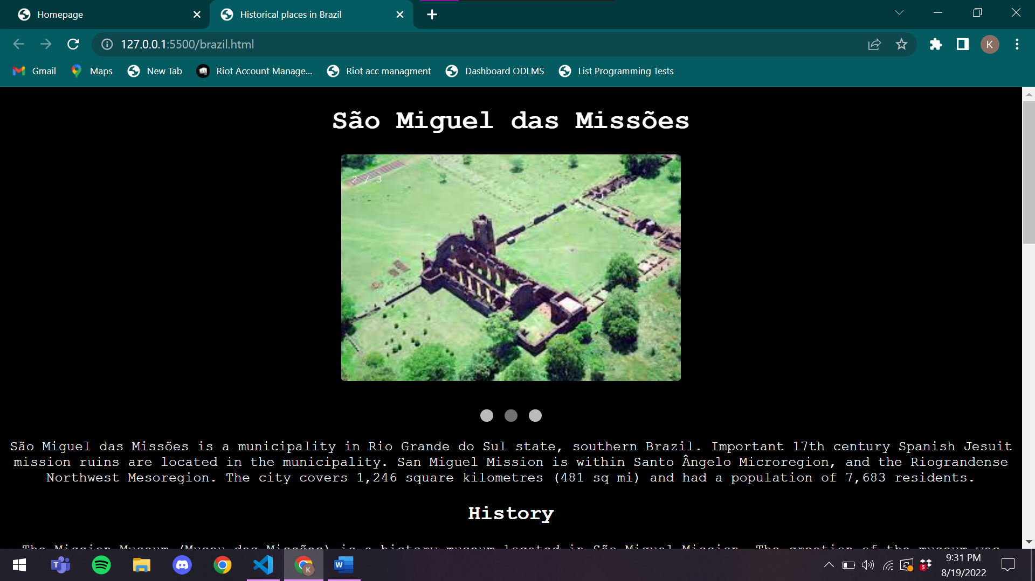

**Code:**

<!DOCTYPE html>

<html lang="en">

<head>

    <meta charset="UTF-8">

    <meta http-equiv="X-UA-Compatible" content="IE=edge">

    <meta name="viewport" content="width=device-width, initial-scale=1.0">

    <title>Historical places in Brazil</title>

    <style>

        body{

            font-family: 'Courier New', Courier, monospace;

            text-align: center;

            color: white;

            background-color: black;

        }

        img{

            border-radius: 4px;

        }

        div{

            margin-top: 15px;

        }

        * {box-sizing: border-box;}

        .mySlides {display: none;}

        img {vertical-align: middle;}

        .slideshow-container {

            max-width: 400px;

            position: relative;

            margin: auto;

        }

        .text {

        color: #f2f2f2;

        font-size: 15px;

        padding: 8px 12px;

        position: absolute;

        bottom: 8px;

        width: 100%;

        text-align: center;

        }

        .numbertext {

        color: #f2f2f2;

        font-size: 12px;

        padding: 8px 12px;

        position: absolute;

        top: 0;

        }

        .dot {

        height: 15px;

        width: 15px;

        margin: 0 2px;

        background-color: #bbb;

        border-radius: 50%;

        display: inline-block;

        transition: background-color 0.6s ease;

        }

        .active {

        background-color: #717171;

        }

        .fade {

        animation-name: fade;

        animation-duration: 1.5s;

        }

        @keyframes fade {

        from {opacity: .4}

        to {opacity: 1}

        }

        @media only screen and (max-width: 300px) {

        .text {font-size: 11px}

        }

    </style>

</head>

<body>

    <h1>São Miguel das Missões</h1>

    <div class="slideshow-container">

        <div class="mySlides fade">

          <div class="numbertext">1 / 3</div>

          <img src="/brazil/bra1.jpeg" style="width:100%">

        </div>

        <div class="mySlides fade">

          <div class="numbertext">2 / 3</div>

          <img src="/brazil/bra2.jpeg" style="width:100%">

        </div>

        <div class="mySlides fade">

          <div class="numbertext">3 / 3</div>

          <img src="/brazil/bra3.jpeg" style="width:100%">

        </div>

        </div>

        <br>

        <div style="text-align:center">

          <span class="dot"></span>

          <span class="dot"></span>

          <span class="dot"></span>

        </div>

    <div>

        São Miguel das Missões is a municipality in Rio Grande do Sul state, southern Brazil. Important 17th century Spanish Jesuit mission ruins are located in the municipality. San Miguel Mission is within Santo Ângelo Microregion, and the Riograndense Northwest Mesoregion. The city covers 1,246 square kilometres (481 sq mi) and had a population of 7,683 residents.

    </div>

    <h2>History</h2>

    <div>

        The Mission Museum (Museu das Missões) is a history museum located in São Miguel Mission.

        The creation of the museum was one of the first initiatives of the Office of Historical and Artistic Heritage, today IPHAN. In 1937 the SPHAN was created and in the same year, the architect Lucio Costa was sent to Rio Grande do Sul to analyze the remains of the ruins of the Seven Peoples of the Missions, and propose measures. One of his proposals was to create a museum to house the statues missionaries dispersed throughout the region. In 1938, the remnants of the town of San Miguel and the museum building were listed as National Heritage, and in 1940, the Museum of the Missions was officially established.

        Between 1938 and 1940, the architect Lucas Mayerhofer directed the stabilization works in the mission Church of San Miguel, the construction of the museum building, and was in charge of gathering the works of statuary.

        Currently listed in the museum's collection are religious images from the time of installation of the Jesuit missions in the region.

    </div>

    <h1>Christ the Redeemer</h1>

    <div class="slideshow-container">

        <div class="mySlides fade">

          <div class="numbertext">1 / 3</div>

          <img src="/brazil/bra4.jpeg" style="width:100%">

        </div>

        <div class="mySlides fade">

          <div class="numbertext">2 / 3</div>

          <img src="/brazil/bra5.jpeg" style="width:100%">

        </div>

        <div class="mySlides fade">

          <div class="numbertext">3 / 3</div>

          <img src="/brazil/bra6.jpeg" style="width:100%">

        </div>

        </div>

        <br>

        <div style="text-align:center">

          <span class="dot"></span>

          <span class="dot"></span>

          <span class="dot"></span>

        </div>

    <div>

        Christ the Redeemer (Portuguese: Cristo Redentor, standard Brazilian Portuguese: [ˈkɾistu ʁedẽˈtoʁ], local pronunciation: [ˈkɾiɕtŭ̥ xe̞dẽˈtoɦ]) is an Art Deco statue of Jesus Christ in Rio de Janeiro, Brazil, created by French sculptor Paul Landowski and built by Brazilian engineer Heitor da Silva Costa, in collaboration with French engineer Albert Caquot. Romanian sculptor Gheorghe Leonida fashioned the face. Constructed between 1922 and 1931, the statue is 30 metres (98 ft) high, excluding its 8-metre (26 ft) pedestal. The arms stretch 28 metres (92 ft) wide.[1][2] It is made of reinforced concrete and soapstone.[3][4][5] The Christ the Redeemer differs considerably from its original design. The initial plan was a large Christ with a globe in one hand and a cross in the other. Although the project organisers originally accepted the design, it later changed to the statue of today, with the arms spread out wide.

        The statue weighs 635 metric tons (625 long, 700 short tons), and is located at the peak of the 700-metre (2,300 ft) Corcovado mountain in the Tijuca National Park overlooking the city of Rio de Janeiro. A symbol of Christianity around the world, the statue has also become a cultural icon of both Rio de Janeiro and Brazil and was voted one of the New Seven Wonders of the World

    </div>

    <h2>History</h2>

    <div>

        Vincentian priest Pedro Maria Boss first suggested placing a Christian monument on Mount Corcovado in the mid-1850s to honor Princess Isabel, regent of Brazil and the daughter of Emperor Pedro II, but the project was not approved.[1] In 1889 the country became a republic, and owing to the separation of church and state the proposed statue was dismissed.

        The Catholic Circle of Rio made a second proposal for a landmark statue on the mountain in 1920.[8] The group organized an event called Semana do Monumento ("Monument Week") to attract donations and collect signatures to support the building of the statue. The organization was motivated by what they perceived as "Godlessness" in the society. The donations came mostly from Brazilian Catholics.[3] The designs considered for the "Statue of the Christ" included a representation of the Christian cross, a statue of Jesus with a globe in his hands, and a pedestal symbolizing the world.[9] The statue of Christ the Redeemer with open arms, a symbol of peace, was chosen.

        Local engineer Heitor da Silva Costa and artist Carlos Oswald designed the statue.[10] French sculptor Paul Landowski created the work.[11]

        In 1922, Landowski commissioned fellow Parisian Romanian sculptor Gheorghe Leonida, who studied sculpture at the Fine Arts Conservatory in Bucharest and in Italy.[12]

        A group of engineers and technicians studied Landowski's submissions and felt building the structure of reinforced concrete (designed by Albert Caquot) instead of steel was more suitable for the cross-shaped statue. The concrete making up the base was supplied from Limhamn, Sweden.[13][14] The outer layers are soapstone, chosen for its enduring qualities and ease of use.Construction took nine years, from 1922 to 1931, and cost the equivalent of US$250,000 (equivalent to $3,800,000 in 2021) and the monument opened on October 12, 1931.[4][5] During the opening ceremony, the statue was to be lit by a battery of floodlights turned on remotely by Italian shortwave radio inventor Guglielmo Marconi, stationed 9,200 kilometres (5,700 mi) away in Rome but because of bad weather, the lights were activated on site.[8]

        In October 2006, on the 75th anniversary of the statue's completion, Cardinal Eusebio Oscar Scheid, Archbishop of Rio, consecrated a chapel, named after Brazil's patron saint—Our Lady of the Apparition—under the statue, allowing Catholics to hold baptisms and weddings there.[5]

        Lightning struck the statue during a violent thunderstorm on February 10, 2008, causing some damage to the fingers, head and eyebrows. The Rio de Janeiro state government initiated a restoration effort to replace some of the outer soapstone layers and repair the lightning rods on the statue. Lightning damaged it again on January 17, 2014, dislodging a finger on the right hand.

        In 2010, a massive restoration of the statue began. Work included cleaning, replacing the mortar and soapstone on the exterior, restoring iron in the internal structure, and waterproofing the monument. Vandals attacked the statue during renovation, spraying paint along the arm. Mayor Eduardo Paes called the act "a crime against the nation". The culprits later apologized and presented themselves to the police.

        In reference to Brazil striker Ronaldo's usual goal celebration of both arms outstretched, the Pirelli tyre company ran a 1998 commercial in which he replaced the statue while in an Inter Milan strip.[22] The commercial was controversial with the Catholic Church.[23]

    </div>

    <script>

        let slideIndex = 0;

        showSlides();

        function showSlides() {

          let i;

          let slides = document.getElementsByClassName("mySlides");

          let dots = document.getElementsByClassName("dot");

          for (i = 0; i < slides.length; i++) {

            slides[i].style.display = "none";

          }

          slideIndex++;

          if (slideIndex > slides.length) {slideIndex = 1}

          for (i = 0; i < dots.length; i++) {

            dots[i].className = dots[i].className.replace(" active", "");

          }

          slides[slideIndex-1].style.display = "block";

          dots[slideIndex-1].className += " active";

          setTimeout(showSlides, 2000); // Change image every 2 seconds

        }

    </script>

</body>

</html>

**Webpage for Bulgaria:**

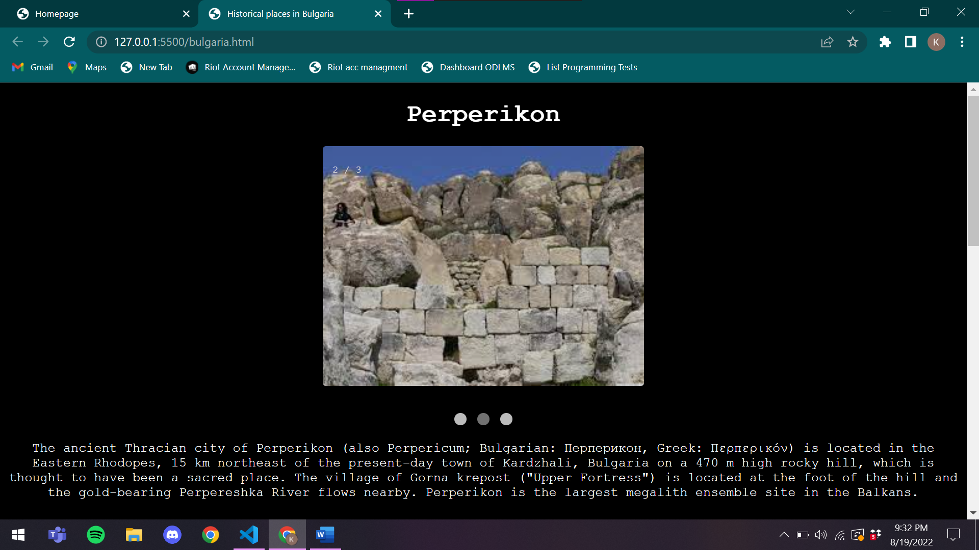

**Code:**

<!DOCTYPE html>

<html lang="en">

<head>

    <meta charset="UTF-8">

    <meta http-equiv="X-UA-Compatible" content="IE=edge">

    <meta name="viewport" content="width=device-width, initial-scale=1.0">

    <title>Historical places in Bulgaria</title>

    <style>

        body{

            font-family: 'Courier New', Courier, monospace;

            text-align: center;

            color: white;

            background-color: black;

        }

        img{

            border-radius: 4px;

        }

        div{

            margin-top: 15px;

        }

        * {box-sizing: border-box;}

        .mySlides {display: none;}

        img {vertical-align: middle;}

        .slideshow-container {

            max-width: 400px;

            position: relative;

            margin: auto;

        }

        .text {

        color: #f2f2f2;

        font-size: 15px;

        padding: 8px 12px;

        position: absolute;

        bottom: 8px;

        width: 100%;

        text-align: center;

        }

        .numbertext {

        color: #f2f2f2;

        font-size: 12px;

        padding: 8px 12px;

        position: absolute;

        top: 0;

        }

        .dot {

        height: 15px;

        width: 15px;

        margin: 0 2px;

        background-color: #bbb;

        border-radius: 50%;

        display: inline-block;

        transition: background-color 0.6s ease;

        }

        .active {

        background-color: #717171;

        }

        .fade {

        animation-name: fade;

        animation-duration: 1.5s;

        }

        @keyframes fade {

        from {opacity: .4}

        to {opacity: 1}

        }

        @media only screen and (max-width: 300px) {

        .text {font-size: 11px}

        }

    </style>

</head>

<body>

    <h1>Perperikon</h1>

    <div class="slideshow-container">

        <div class="mySlides fade">

          <div class="numbertext">1 / 3</div>

          <img src="/bulgaria/bul1.jpeg" style="width:100%">

        </div>

        <div class="mySlides fade">

          <div class="numbertext">2 / 3</div>

          <img src="/bulgaria/bul2.jpeg" style="width:100%">

        </div>

        <div class="mySlides fade">

          <div class="numbertext">3 / 3</div>

          <img src="/bulgaria/bul3.jpeg" style="width:100%">

        </div>

        </div>

        <br>

        <div style="text-align:center">

          <span class="dot"></span>

          <span class="dot"></span>

          <span class="dot"></span>

        </div>

    <div>

        The ancient Thracian city of Perperikon (also Perpericum; Bulgarian: Перперикон, Greek: Περπερικόν) is located in the Eastern Rhodopes, 15 km northeast of the present-day town of Kardzhali, Bulgaria on a 470 m high rocky hill, which is thought to have been a sacred place. The village of Gorna krepost ("Upper Fortress") is located at the foot of the hill and the gold-bearing Perpereshka River flows nearby. Perperikon is the largest megalith ensemble site in the Balkans.

    </div>

    <h2>History</h2>

    <div>

        Human activity in the area dates back to 5000 BCE. The first traces of civilization on the hill date from the Bronze Age, while the ceramics found on the place date from the Early Iron Age, as well as the impressive round altar, almost 2 m in diameter, hewn out of the rocks.

        It is thought that a famous Temple of Dionysus was located at Perperikon during the classical era.[2]

        Perperikon is the site from which Medokos declared himself the king of Thrace in 424 BCE, after Sitalces's death, but was overthrown.[3]

        Bulgarian archaeologist Nikolay Ovcharov started the excavation works at Perperikon in 2000, and revealed the remains of ancient architectural complex.[4]

        Archaeologists have uncovered a giant multi-story palace and an imposing fortress built around the hill, with walls as thick as 2.8 m. This dates from the time of the Roman Empire. Temples and residential quarters were also constructed in the fortress. The megalithic complex has been laid in ruins and re-erected many times throughout history.

        A 2.4 million Euro visitor centre is being constructed with funds provided by the EU/bulgaria/bul4.jpeg</h1>

    <div class="slideshow-container">

        <div class="mySlides fade">

          <div class="numbertext">1 / 3</div>

          <img src="/bulgaria/bul4.jpeg" style="width:100%">

        </div>

        <div class="mySlides fade">

          <div class="numbertext">2 / 3</div>

          <img src="/bulgaria/bul5.jpeg" style="width:100%">

        </div>

        <div class="mySlides fade">

          <div class="numbertext">3 / 3</div>

          <img src="/bulgaria/bul6.jpeg" style="width:100%">

        </div>

        </div>

        <br>

        <div style="text-align:center">

          <span class="dot"></span>

          <span class="dot"></span>

          <span class="dot"></span>

        </div>

        <h1>Pliska</h1>

    <div>

        Pliska (Bulgarian: Плиска [ˈpliskɐ], Church Slavonic: Пльсковъ, romanized: Plĭskovŭ) was the first capital of the First Bulgarian Empire during the Middle Ages and is now a small town in Shumen Province, on the Ludogorie plateau of the Danubian Plain, 20 km northeast of the provincial capital, Shumen.

        Pliska was the first capital of Bulgaria, and according to legend founded by Asparuh of Bulgaria in the late 7th century; this legend is archaeologically unsubstantiated.[1] The site was originally an encampment, with the first tent-shaped buildings at Pliska of uncertain date.[1] No evidence exists of a settlement before the 9th century, and claims that the site dates from Late Antiquity have been contested.[2]

        By the early 9th century, Pliska was surrounded by a defensive wall and 2,300 hectares (5,700 acres) of land was further enclosed by an outer earthwork with stone revetment 21 kilometres (13 miles) long.[1] After the Byzantine army sacked and burned Pliska in 811, led by the emperor Nikephoros I (r. 802–811), Pliska was rebuilt by Omurtag (r. 814–831), who used spolia from nearby Roman buildings and employing late Roman-inspired rectilinear and basilica plans in the architecture of his new ashlar palace, which descended from Late Antique prototypes like Diocletian's Palace at Split, Croatia.[1] When Boris I (r. 852–889) converted to Christianity in 864, the religious buildings of Pliska were adapted for Christian use and it was after this point that the Great Basilica was constructed, together with a monastery which was attached to it.[1] The monastery was home to the disciples of Saints Cyril and Methodius.[1]

        After the tsar Simeon I founded his new capital at Preslav, Pliska was slowly abandoned. Pliska (Medieval Greek: Πλίσκοβα, romanized: Plískova) was captured at the turn of the 2nd millennium by Theodorokanos and Nikephoros Xiphias, during the campaigns of the emperor Basil the Bulgar-Slayer (r. 960–1025), which ended the First Bulgarian Empire.[1]

    </div>

    <h2>History</h2>

    <div>

        In 680 CE, Bulgars crossed the Danube and invaded lands now part of modern-day Bulgaria, which was at that time largely inhabited by Slavic farmers.[3] The Bulgar army was led by Asparukh, who according to Byzantine chroniclers was one of the five sons of Kubrat, the Onogur chief who revolted against his Avar rulers and succeeded in uniting the various Bulgar groups living north of the Black Sea.[4] When Asparukh and his warriors entered the region south of the Danube, the Byzantine Emperor Constantine IV was upset and led an army to prevent the Bulgars from remaining there. The Byzantine expedition against the Bulgars ended disastrously and after defeating the imperial forces, Asparukh forced the nearby Slavic tribes to pay tribute to him, while leaving their tribal organization intact. As a result of this defeat, the empire was forced to sign a treaty recognizing the Bulgar state in 681. Despite the area having been for some time under the de facto control of various Slavic tribes, the emperors of Byzantium had kept up the fiction that the area was still imperial, as up to 681 no true state had replaced imperial rule. This was the first time that the Byzantine empire officially acknowledged another state in the Balkans.[4]

    </div>

    <script>

        let slideIndex = 0;

        showSlides();

        function showSlides() {

          let i;

          let slides = document.getElementsByClassName("mySlides");

          let dots = document.getElementsByClassName("dot");

          for (i = 0; i < slides.length; i++) {

            slides[i].style.display = "none";

          }

          slideIndex++;

          if (slideIndex > slides.length) {slideIndex = 1}

          for (i = 0; i < dots.length; i++) {

            dots[i].className = dots[i].className.replace(" active", "");

          }

          slides[slideIndex-1].style.display = "block";

          dots[slideIndex-1].className += " active";

          setTimeout(showSlides, 2000); // Change image every 2 seconds

        }

    </script>

</body>

</html>

**Webpage for Canada:**

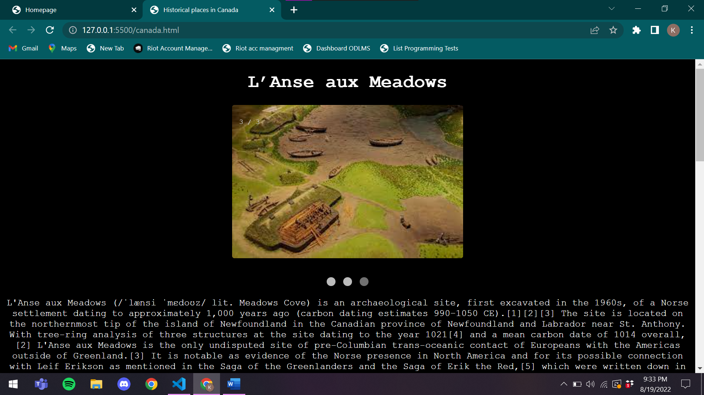

**Code:**

<!DOCTYPE html>

<html lang="en">

<head>

    <meta charset="UTF-8">

    <meta http-equiv="X-UA-Compatible" content="IE=edge">

    <meta name="viewport" content="width=device-width, initial-scale=1.0">

    <title>Historical places in Canada</title>

    <style>

        body{

            font-family: 'Courier New', Courier, monospace;

            text-align: center;

            color: white;

            background-color: black;

        }

        img{

            border-radius: 4px;

        }

        div{

            margin-top: 15px;

        }

        * {box-sizing: border-box;}

        .mySlides {display: none;}

        img {vertical-align: middle;}

        .slideshow-container {

            max-width: 400px;

            position: relative;

            margin: auto;

        }

        .text {

        color: #f2f2f2;

        font-size: 15px;

        padding: 8px 12px;

        position: absolute;

        bottom: 8px;

        width: 100%;

        text-align: center;

        }

        .numbertext {

        color: #f2f2f2;

        font-size: 12px;

        padding: 8px 12px;

        position: absolute;

        top: 0;

        }

        .dot {

        height: 15px;

        width: 15px;

        margin: 0 2px;

        background-color: #bbb;

        border-radius: 50%;

        display: inline-block;

        transition: background-color 0.6s ease;

        }

        .active {

        background-color: #717171;

        }

        .fade {

        animation-name: fade;

        animation-duration: 1.5s;

        }

        @keyframes fade {

        from {opacity: .4}

        to {opacity: 1}

        }

        @media only screen and (max-width: 300px) {

        .text {font-size: 11px}

        }

    </style>

</head>

<body>

    <h1>L’Anse aux Meadows</h1>

    <div class="slideshow-container">

        <div class="mySlides fade">

          <div class="numbertext">1 / 3</div>

          <img src="/canada/can1.jpeg" style="width:100%">

        </div>

        <div class="mySlides fade">

          <div class="numbertext">2 / 3</div>

          <img src="/canada/can2.jpeg" style="width:100%">

        </div>

        <div class="mySlides fade">

          <div class="numbertext">3 / 3</div>

          <img src="/canada/can3.jpeg" style="width:100%">

        </div>

        </div>

        <br>

        <div style="text-align:center">

          <span class="dot"></span>

          <span class="dot"></span>

          <span class="dot"></span>

        </div>

    <div>

        L'Anse aux Meadows (/ˈlænsi ˈmɛdoʊz/ lit. Meadows Cove) is an archaeological site, first excavated in the 1960s, of a Norse settlement dating to approximately 1,000 years ago (carbon dating estimates 990–1050 CE).[1][2][3] The site is located on the northernmost tip of the island of Newfoundland in the Canadian province of Newfoundland and Labrador near St. Anthony.

        With tree-ring analysis of three structures at the site dating to the year 1021[4] and a mean carbon date of 1014 overall,[2] L'Anse aux Meadows is the only undisputed site of pre-Columbian trans-oceanic contact of Europeans with the Americas outside of Greenland.[3] It is notable as evidence of the Norse presence in North America and for its possible connection with Leif Erikson as mentioned in the Saga of the Greenlanders and the Saga of Erik the Red,[5] which were written down in the 13th century.[3] Archaeological evidence found at the site indicates that L’Anse aux Meadows may have served as a base camp for Norse exploration of North America, including regions to the south.[6]

        Spanning 7,991 hectares (30.85 sq mi) of land and sea, the site contains the remains of eight buildings constructed with sod over a wood frame. In excess of 800 Norseman objects have been unearthed at the site.[7] Evidence of iron production and bronze, bone and stone artifacts have been identified.[8] The site was designated a National Historic Site of Canada in 1968 and a World Heritage Site by UNESCO in 1978.[9] Parks Canada manages the site as outlined under the Parks Canada Agency Act (1998) and the Canada National Parks Act (2000).[10] It is the only confirmed Norse site in or near North America outside of the villages and settlements of Greenland

    </div>

    <h2>History</h2>

    <div>

        Before the Norse arrived in Newfoundland, there is evidence of occupations by five Indigenous groups at the site of L'Anse aux Meadows, the oldest dated at roughly 6,000 years ago. None were contemporaneous with the Norse occupation. The most prominent of these earlier occupations was by the Dorset people, who occupied the site about 300 years before the Norse. Birgitta Wallace gives radiocarbon date ranges for these groups of c. 4000–1000 BCE for the Maritime Archaic tradition, c. 1000–500 BCE for the Groswater tradition, c. 400–750 CE for the Middle Dorset, c. 800–850 CE for the Cow Head Group and Beaches traditions, and c. 1200–1500 CE for the Little Passage traditi/canada/can4.jpeg</h1>

    <div class="slideshow-container">

        <div class="mySlides fade">

          <div class="numbertext">1 / 3</div>

          <img src="/canada/can4.jpeg" style="width:100%">

        </div>

        <div class="mySlides fade">

          <div class="numbertext">2 / 3</div>

          <img src="/canada/can5.jpeg" style="width:100%">

        </div>

        <div class="mySlides fade">

          <div class="numbertext">3 / 3</div>

          <img src="/canada/can6.jpeg" style="width:100%">

        </div>

        </div>

        <br>

        <div style="text-align:center">

          <span class="dot"></span>

          <span class="dot"></span>

          <span class="dot"></span>

        </div>

    <h1>The Citadelle of Quebec</h1>

    <div>

        The Citadelle of Quebec (French: Citadelle de Québec), also known as La Citadelle, is an active military installation and the secondary official residence of both the Canadian monarch and the governor general of Canada.[2][3] It is located atop Cap Diamant, adjoining the Plains of Abraham in Quebec City, Quebec. The citadel contains the oldest military building in Canada, and forms part of the fortifications of Quebec City, which is one of only two cities in North America still surrounded by fortifications, the other being Campeche, Mexico.

        The strategic importance of Cap Diamant was recognized by the French as early as 1608. Several defensive fortifications were built on the site first by the French, and then by the British after their conquest of New France. The modern citadel was built from 1820 to 1850, in effort to secure Quebec City against a potential American attack. The British used the citadel until 1871, when they formally handed the property over to the Canadian government. Following the handover, the citadel was used as a military installation by the Canadian Armed Forces, and as a royal and viceregal residence.

        The Citadelle is a National Historic Site of Canada[1] and forms part of the Fortifications of Québec National Historic Site of Canada.[4] The fortress is located within the Historic District of Old Québec, which was designated a World Heritage Site in 1985.[5] The site receives some 200,000 visitors annually.

    </div>

    <h2>History</h2>

    <div>

        As tensions between the United Kingdom and the United States, as well as fears of further rebellion in British North America,[6] grew in the late 18th century, the British reinforced the defences of their colonies according to a plan drawn up in the 1790s by Gother Mann.[9] The ramparts around the Upper Town cliff and four martello towers (still extant) on the Plains of Abraham were completed before 1812. A citadel was a key part of Mann's design, but no fort was built because the cost was deemed prohibitive.[9]

        That opinion finally shifted following the War of 1812;[10] as part of a wider improvement of Canada's defences coordinated by the Duke of Richmond, then Governor-in-Chief of British North America,[10] the existing star fort was built between 1820 and 1850 under the direction of Lieutenant Colonel Elias Walker Durnford of the Royal Engineers. Intended to secure Quebec City against the Americans and serve as a refuge for the British garrison in the event of attack or rebellion, the Citadelle incorporated a section of the French enceinte of 1745 and the layout was based on Sébastien Le Prestre de Vauban's design for an arms, munitions, and supplies depot, as well as a barracks. That, though, was somewhat of an anachronism by the time of the fort's completion, in comparison to other contemporary European military architecture.[9] Additional buildings were completed in 1850.[9]

        After Canadian Confederation in 1867, Canada became responsible for its own defence; the British departed the Citadelle in 1871.[9] Two batteries of the Royal Canadian Artillery were established at the Citadelle and an artillery school was opened in 1871, followed by a cavalry school.[11] From the late 19th century, living conditions for soldiers at the fort gradually improved; canteens were opened and the casemates were made more comfortable.[11] The preservation of much of the fortifications and defences of Quebec is due to the intervention of Governor General of Canada the Marquess of Dufferin and Ava, who also established the Citadelle as a viceregal residence in 1872,[12] reviving a tradition dating to the founding of New France.[13] Since 1920, the Citadelle has been the home station of the Royal 22e Régiment of the Canadian Forces.

        The Quebec Conferences of 1943 and 1944, in which Governor General of Canada the Earl of Athlone, Prime Minister of Canada William Lyon Mackenzie King, British Prime Minister Winston Churchill, and US President Franklin D. Roosevelt discussed strategy for World War II, were held at the Citadelle of Quebec.

        The Historic Sites and Monuments Board of Canada designated the Citadel as a national historic site in 1946.[9] The fortress was designated as a National Historic Site of Canada in 1980 and, five years later, the Historic District of Old Québec, of which the Citadelle is a part, was placed on UNESCO's list of World Heritage Sites.

    </div>

    <script>

        let slideIndex = 0;

        showSlides();

        function showSlides() {

          let i;

          let slides = document.getElementsByClassName("mySlides");

          let dots = document.getElementsByClassName("dot");

          for (i = 0; i < slides.length; i++) {

            slides[i].style.display = "none";

          }

          slideIndex++;

          if (slideIndex > slides.length) {slideIndex = 1}

          for (i = 0; i < dots.length; i++) {

            dots[i].className = dots[i].className.replace(" active", "");

          }

          slides[slideIndex-1].style.display = "block";

          dots[slideIndex-1].className += " active";

          setTimeout(showSlides, 2000); // Change image every 2 seconds

        }

    </script>

</body>

</html>

**WebPage for Croatia:**

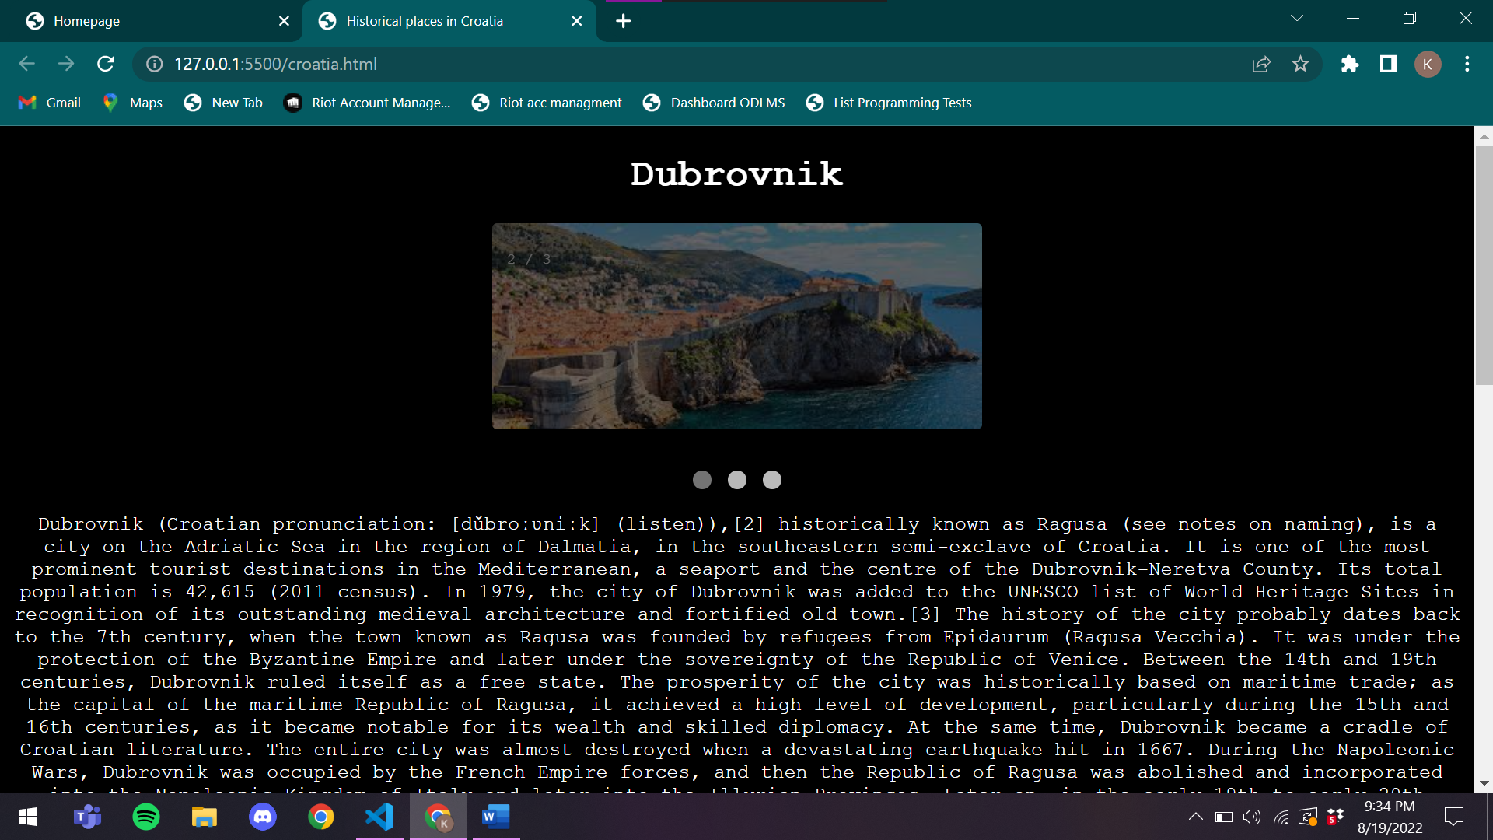

**Code:**

<!DOCTYPE html>

<html lang="en">

<head>

    <meta charset="UTF-8">

    <meta http-equiv="X-UA-Compatible" content="IE=edge">

    <meta name="viewport" content="width=device-width, initial-scale=1.0">

    <title>Historical places in Croatia</title>

    <style>

        body{

            font-family: 'Courier New', Courier, monospace;

            text-align: center;

            color: white;

            background-color: black;

        }

        img{

            border-radius: 4px;

        }

        div{

            margin-top: 15px;

        }

        * {box-sizing: border-box;}

        .mySlides {display: none;}

        img {vertical-align: middle;}

        .slideshow-container {

            max-width: 400px;

            position: relative;

            margin: auto;

        }

        .text {

        color: #f2f2f2;

        font-size: 15px;

        padding: 8px 12px;

        position: absolute;

        bottom: 8px;

        width: 100%;

        text-align: center;

        }

        .numbertext {

        color: #f2f2f2;

        font-size: 12px;

        padding: 8px 12px;

        position: absolute;

        top: 0;

        }

        .dot {

        height: 15px;

        width: 15px;

        margin: 0 2px;

        background-color: #bbb;

        border-radius: 50%;

        display: inline-block;

        transition: background-color 0.6s ease;

        }

        .active {

        background-color: #717171;

        }

        .fade {

        animation-name: fade;

        animation-duration: 1.5s;

        }

        @keyframes fade {

        from {opacity: .4}

        to {opacity: 1}

        }

        @media only screen and (max-width: 300px) {

        .text {font-size: 11px}

        }

    </style>

</head>

<body>

    <h1>Dubrovnik</h1>

    <div class="slideshow-container">

        <div class="mySlides fade">

          <div class="numbertext">1 / 3</div>

          <img src="/croatia/cro1.jpeg" style="width:100%">

        </div>

        <div class="mySlides fade">

          <div class="numbertext">2 / 3</div>

          <img src="/croatia/cro2.jpeg" style="width:100%">

        </div>

        <div class="mySlides fade">

          <div class="numbertext">3 / 3</div>

          <img src="/croatia/cro3.jpeg" style="width:100%">

        </div>

        </div>

        <br>

        <div style="text-align:center">

          <span class="dot"></span>

          <span class="dot"></span>

          <span class="dot"></span>

        </div>

    <div>

        Dubrovnik (Croatian pronunciation: [dǔbroːʋniːk] (listen)),[2] historically known as Ragusa (see notes on naming), is a city on the Adriatic Sea in the region of Dalmatia, in the southeastern semi-exclave of Croatia. It is one of the most prominent tourist destinations in the Mediterranean, a seaport and the centre of the Dubrovnik-Neretva County. Its total population is 42,615 (2011 census). In 1979, the city of Dubrovnik was added to the UNESCO list of World Heritage Sites in recognition of its outstanding medieval architecture and fortified old town.[3]

        The history of the city probably dates back to the 7th century, when the town known as Ragusa was founded by refugees from Epidaurum (Ragusa Vecchia). It was under the protection of the Byzantine Empire and later under the sovereignty of the Republic of Venice. Between the 14th and 19th centuries, Dubrovnik ruled itself as a free state. The prosperity of the city was historically based on maritime trade; as the capital of the maritime Republic of Ragusa, it achieved a high level of development, particularly during the 15th and 16th centuries, as it became notable for its wealth and skilled diplomacy. At the same time, Dubrovnik became a cradle of Croatian literature.

        The entire city was almost destroyed when a devastating earthquake hit in 1667. During the Napoleonic Wars, Dubrovnik was occupied by the French Empire forces, and then the Republic of Ragusa was abolished and incorporated into the Napoleonic Kingdom of Italy and later into the Illyrian Provinces. Later on, in the early 19th to early 20th century, Dubrovnik was part of the Kingdom of Dalmatia within the Austrian Empire. Dubrovnik became part of the Kingdom of Yugoslavia immediately upon its creation, and it was incorporated into its Zeta Banovina in 1929, before becoming part of the Banovina of Croatia upon its creation in 1939. During World War II, it was part of the Axis puppet state Independent State of Croatia, before being reincorporated into SR Croatia in SFR Yugoslavia.

        In 1991, during the Croatian War of Independence, Dubrovnik was besieged by the Yugoslav People's Army for seven months and suffered significant damage from shelling. After undergoing repair and restoration works in the 1990s and early 2000s, it re-emerged as one of the Mediterranean's top tourist destinations, as well as a popular filming location.

    </div>

    <h2>History</h2>

    <div>

        Dubrovnik was inhabited by the Illyrian tribe of Dalmatae in ancient times. According to Constantine Porphyrogenitus's De Administrando Imperio (c. 950), Ragusa was founded in the 7th century, named after a "rocky island" called Lausa, by refugees from Epidaurum (Ragusa Vecchia), a Roman city situated some 15 km to the south, when that city was destroyed by Slavs fighting with the Avars.[12]

        Excavations in 2007 revealed a Byzantine basilica from the 8th century and parts of the city walls. The size of the old basilica clearly indicates that there was quite a large settlement at the time. There is also evidence for the presence of a settlement in the pre-Christian era.[13]

        Antun Ničetić, in his 1996 book Povijest dubrovačke luke ("History of the Port of Dubrovnik"), expounds the theory that Dubrovnik was established by Greek sailors,[citation needed] as a station halfway between the two Greek settlements of Budva and Korčula, 95 nautical miles (176 km; 109 mi) apart from each of them.

    </div>

    <h1>Pula Arena</h1>

    <div class="slideshow-container">

        <div class="mySlides fade">

          <div class="numbertext">1 / 3</div>

          <img src="/croatia/cro4.jpeg" style="width:100%">

        </div>

        <div class="mySlides fade">

          <div class="numbertext">2 / 3</div>

          <img src="/croatia/cro5.jpeg" style="width:100%">

        </div>

        <div class="mySlides fade">

          <div class="numbertext">3 / 3</div>

          <img src="/croatia/cro6.jpeg" style="width:100%">

        </div>

        </div>

        <br>

        <div style="text-align:center">

          <span class="dot"></span>

          <span class="dot"></span>

          <span class="dot"></span>

        </div>

    <div>

        The Pula Arena (Croatian: Pulska Arena; Italian: Arena di Pola) is a Roman amphitheatre located in Pula, Croatia. It is the only remaining Roman amphitheatre to have four side towers entirely preserved. It was constructed between 27 BC and AD 68,[1] and is among the world's six largest surviving Roman arenas.[1] The arena is also the country's best-preserved ancient monument.

        Restored arched walls at Pula. The amphitheatre is depicted on the reverse of the Croatian 10 kuna banknote, issued in 1993, 1995, 2001 and 2004.[

    </div>

    <h2>History</h2>

    <div>

        The Arena was built between 27 BC and 68 AD,[1] as the city of Pula became a regional centre of Roman rule, called Pietas Julia. The name was derived from the sand that, since antiquity, covered the inner space. It was built outside the town walls along the Via Flavia, the road from Pula to Aquileia and Rome.[5]

        The amphitheatre was first built in timber during the reign of Augustus (2–14 AD). It was replaced by a small stone amphitheatre during the reign of emperor Claudius. In 79 AD it was enlarged to accommodate gladiator fights by Vespasian and to be completed in 81 AD under emperor Titus. This was confirmed by the discovery of a Vespasian coin in the malting.[5]

        St. Germanus, of whom little is known, was allegedly tortured in the Amphitheatre in or around 290, and subsequently martyred outside the city, on the road to Nesactium. The legend is apocryphal. The amphitheatre remained in use until the 5th century, when emperor Honorius prohibited gladiatorial combats. It was not until 681 that combat between convicts, particularly those sentenced to death, and wild animals was forbidden. In the 5th century the amphitheatre began to see its stone plundered by the local populace. By the 13th century, the patriarch of Aquileia forbade further removal from the Arena.

    </div>

    <script>

        let slideIndex = 0;

        showSlides();

        function showSlides() {

          let i;

          let slides = document.getElementsByClassName("mySlides");

          let dots = document.getElementsByClassName("dot");

          for (i = 0; i < slides.length; i++) {

            slides[i].style.display = "none";

          }

          slideIndex++;

          if (slideIndex > slides.length) {slideIndex = 1}

          for (i = 0; i < dots.length; i++) {

            dots[i].className = dots[i].className.replace(" active", "");

          }

          slides[slideIndex-1].style.display = "block";

          dots[slideIndex-1].className += " active";

          setTimeout(showSlides, 2000); // Change image every 2 seconds

        }

    </script>

</body>

</html>

**Webpage for Czech Republic:**

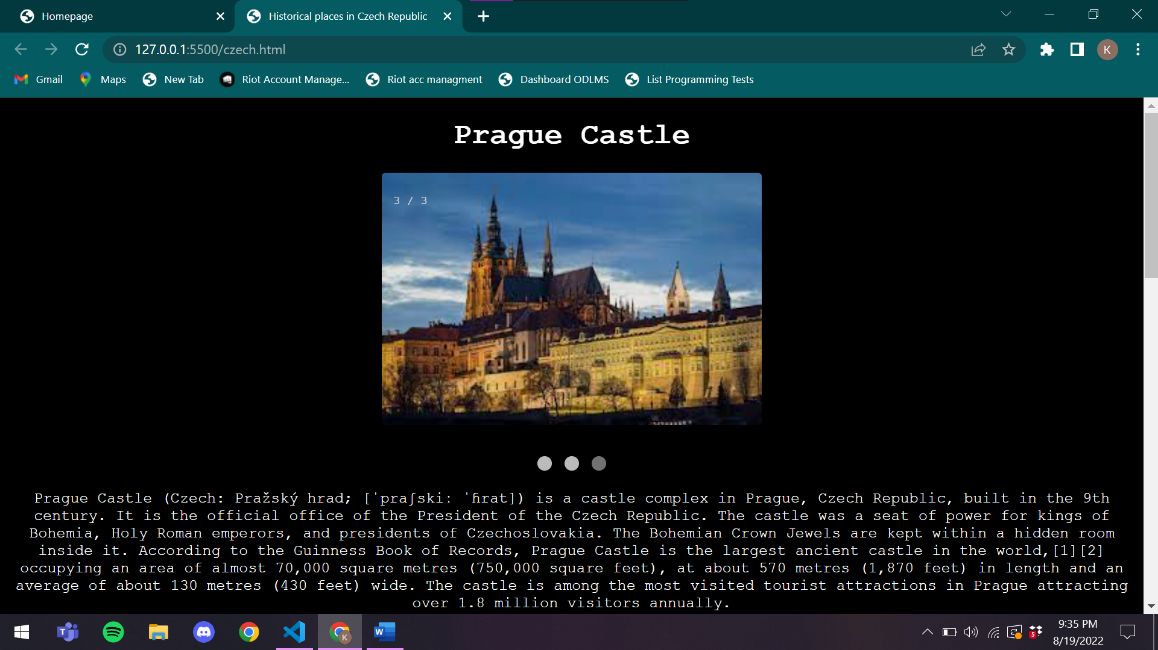

**Code:**

<!DOCTYPE html>

<html lang="en">

<head>

    <meta charset="UTF-8">

    <meta http-equiv="X-UA-Compatible" content="IE=edge">

    <meta name="viewport" content="width=device-width, initial-scale=1.0">

    <title>Historical places in Czech Republic</title>

    <style>

        body{

            font-family: 'Courier New', Courier, monospace;

            text-align: center;

            color: white;

            background-color: black;

        }

        img{

            border-radius: 4px;

        }

        div{

            margin-top: 15px;

        }

        * {box-sizing: border-box;}

        .mySlides {display: none;}

        img {vertical-align: middle;}

        .slideshow-container {

            max-width: 400px;

            position: relative;

            margin: auto;

        }

        .text {

        color: #f2f2f2;

        font-size: 15px;

        padding: 8px 12px;

        position: absolute;

        bottom: 8px;

        width: 100%;

        text-align: center;

        }

        .numbertext {

        color: #f2f2f2;

        font-size: 12px;

        padding: 8px 12px;

        position: absolute;

        top: 0;

        }

        .dot {

        height: 15px;

        width: 15px;

        margin: 0 2px;

        background-color: #bbb;

        border-radius: 50%;

        display: inline-block;

        transition: background-color 0.6s ease;

        }

        .active {

        background-color: #717171;

        }

        .fade {

        animation-name: fade;

        animation-duration: 1.5s;

        }

        @keyframes fade {

        from {opacity: .4}

        to {opacity: 1}

        }

        @media only screen and (max-width: 300px) {

        .text {font-size: 11px}

        }

    </style>

</head>

<body>

    <h1>Prague Castle</h1>

    <div class="slideshow-container">

        <div class="mySlides fade">

          <div class="numbertext">1 / 3</div>

          <img src="/czech/cze1.jpeg" style="width:100%">

        </div>

        <div class="mySlides fade">

          <div class="numbertext">2 / 3</div>

          <img src="/czech/cze2.jpeg" style="width:100%">

        </div>

        <div class="mySlides fade">

          <div class="numbertext">3 / 3</div>

          <img src="/czech/cze3.jpeg" style="width:100%">

        </div>

        </div>

        <br>

        <div style="text-align:center">

          <span class="dot"></span>

          <span class="dot"></span>

          <span class="dot"></span>

        </div>

    <div>

        Prague Castle (Czech: Pražský hrad; [ˈpraʃskiː ˈɦrat]) is a castle complex in Prague, Czech Republic, built in the 9th century. It is the official office of the President of the Czech Republic. The castle was a seat of power for kings of Bohemia, Holy Roman emperors, and presidents of Czechoslovakia. The Bohemian Crown Jewels are kept within a hidden room inside it.

        According to the Guinness Book of Records, Prague Castle is the largest ancient castle in the world,[1][2] occupying an area of almost 70,000 square metres (750,000 square feet), at about 570 metres (1,870 feet) in length and an average of about 130 metres (430 feet) wide. The castle is among the most visited tourist attractions in Prague attracting over 1.8 million visitors annually.

    </div>

    <h2>History</h2>

    <div>

        King Ottokar II of Bohemia improved fortifications and rebuilt the royal palace for the purposes of representation and housing. In the 14th century, under the reign of Charles IV the royal palace was rebuilt in Gothic style and the castle fortifications were strengthened. In place of rotunda and basilica of St. Vitus began building of a vast Gothic church, that were completed almost six centuries later.

        During the Hussite Wars and the following decades, the castle was not inhabited. In 1485, King Vladislaus II Jagiellon began to rebuild the castle. The massive Vladislav Hall (built by Benedikt Rejt) was added to the Royal Palace. New defence towers were also built on the north side of the castle.

        A large fire in 1541 destroyed large parts of the castle. Under the Habsburgs, some new buildings in Renaissance style were added. Ferdinand I built the Belvedere as a summer palace for his wife Anne. Rudolph II used Prague Castle as his main residence. He founded the northern wing of the palace, with the Spanish Hall, where his precious art collections were exhibited.

        The Third Defenestration of Prague in 1618 took place at the castle and began the Bohemian Revolt. During the subsequent wars, the Castle was damaged and dilapidated. Many works from the collection of Rudolph II were looted by Swedes in 1648, in the Battle of Prague (1648) which was the final act of the Thirty Years' War.

        The last major rebuilding of the castle was carried out by Empress Maria Theresa in the second half of the 18th century. Following his abdication in 1848, and the succession of his nephew, Franz Joseph, to the throne, the former emperor, Ferdinand I, made Prague Castle his home.

    </div>

    <h1>St. George's Basilica</h1>

    <div class="slideshow-container">

        <div class="mySlides fade">

          <div class="numbertext">1 / 3</div>

          <img src="/czech/cze4.jpeg" style="width:100%">

        </div>

        <div class="mySlides fade">

          <div class="numbertext">2 / 3</div>

          <img src="/czech/cze5.jpeg" style="width:100%">

        </div>

        <div class="mySlides fade">

          <div class="numbertext">3 / 3</div>

          <img src="/czech/cze6.jpeg" style="width:100%">

        </div>

        </div>

        <br>

        <div style="text-align:center">

          <span class="dot"></span>

          <span class="dot"></span>

          <span class="dot"></span>

        </div>

    <div>

        St. George's Basilica (Czech: Bazilika Sv. Jiří) is the oldest surviving church building within Prague Castle, Prague, Czech Republic. The basilica was founded by Vratislaus I of Bohemia in 920. It is dedicated to Saint George. Primarily Romanesque in style, it is part of the collection of buildings that comprise the castle, the political capital of the nation, and the spiritual center of the Czech state.

    </div>

    <h2>History</h2>

    <div>

        Consecrated in 921, the basilica is one of the oldest churches in Prague built in the Romanesque style.[1] The construction of the church was begun by Vratislaus I. At the time of Vratislaus' death in 921, the church had been completed but not consecrated. Wenceslaus I completed the project, and upon her death he buried his grandmother, Ludmila of Bohemia there.[2]

        The basilica was prominent at the beginning of the spread of Christianity in Bohemia. Its collegiate church was at the center of the territory until the foundation of the Archdiocese of Prague in 973. In 976, the first building of the Benedictine St. George's Abbey was erected on the north side of the basilica, and the basilica served as an abbey church. The original three-nave building was completed with a choir, a tribune for the nuns of the convent and a crypt.[2]

        Founded in 973 by Mlada, the Convent of Saint George sits next to the basilica.[3] The abbess of this community had the right to crown the Bohemian queen consort.

        In 1142, Conrad III entered Bohemia to reinstate his brother-in-law Vladislaus II as duke. Conrad laid siege to the Prague Castle. During the siege, the church and convent suffered heavy damage caused by a fire. The damage was repaired between 1145 and 1151 and two towers were added to the church on that occasion. The northern, smaller tower is nicknamed "Eve", while the southern, larger, tower is nicknamed "Adam".[4] The Baroque façade dates from the late 17th century.[5]

        In the years 1364–1378 the abbess Elisabetta completed the renovation of the chapel of Santa Ludmilla in the Gothic style, while the chapel's altar was consecrated in 1371 by Archbishop Jan Očko of Vlašim. During the 15th century, the monastery was devastated during the Hussite Wars and rebuilt after the return of the Benedictines under Sigismund of Luxembourg. At the beginning of the 16th century, a new southern portal was built. During the fire of 1541, the basilica burned down again and was rebuilt again. Between 1608 and 1612, the Abbess Sophia of Helfenburg had a large choir for the nuns built in the western part of the central nave. In the late 17th century the Baroque façade was built, probably under the direction of Francesco Caratti  [cs].[6] Between 1717 and 1722, the chapel of St. John of Nepomuk was erected by František Maxmilián Kaňka.[7] A bas-relief on the south portal of the building represents Saint George and the Dragon.[8]

        In the 1780s, the condition of the buildings had deteriorated when Joseph II disbanded the monastic orders,[9] and the monastery and basilica were repurposed and used by the army.

        With the exception of some elements of the façade, and interior of the church, the basilica has maintained the Romanesque style from the restoration after the fire in Prague Castle in 1142.[4] A bas-relief on the outside of the building represents Saint George and the dragon.

    </div>

    <script>

        let slideIndex = 0;

        showSlides();

        function showSlides() {

          let i;

          let slides = document.getElementsByClassName("mySlides");

          let dots = document.getElementsByClassName("dot");

          for (i = 0; i < slides.length; i++) {

            slides[i].style.display = "none";

          }

          slideIndex++;

          if (slideIndex > slides.length) {slideIndex = 1}

          for (i = 0; i < dots.length; i++) {

            dots[i].className = dots[i].className.replace(" active", "");

          }

          slides[slideIndex-1].style.display = "block";

          dots[slideIndex-1].className += " active";

          setTimeout(showSlides, 2000); // Change image every 2 seconds

        }

    </script>

</body>

</html>

**Webpage for India:**

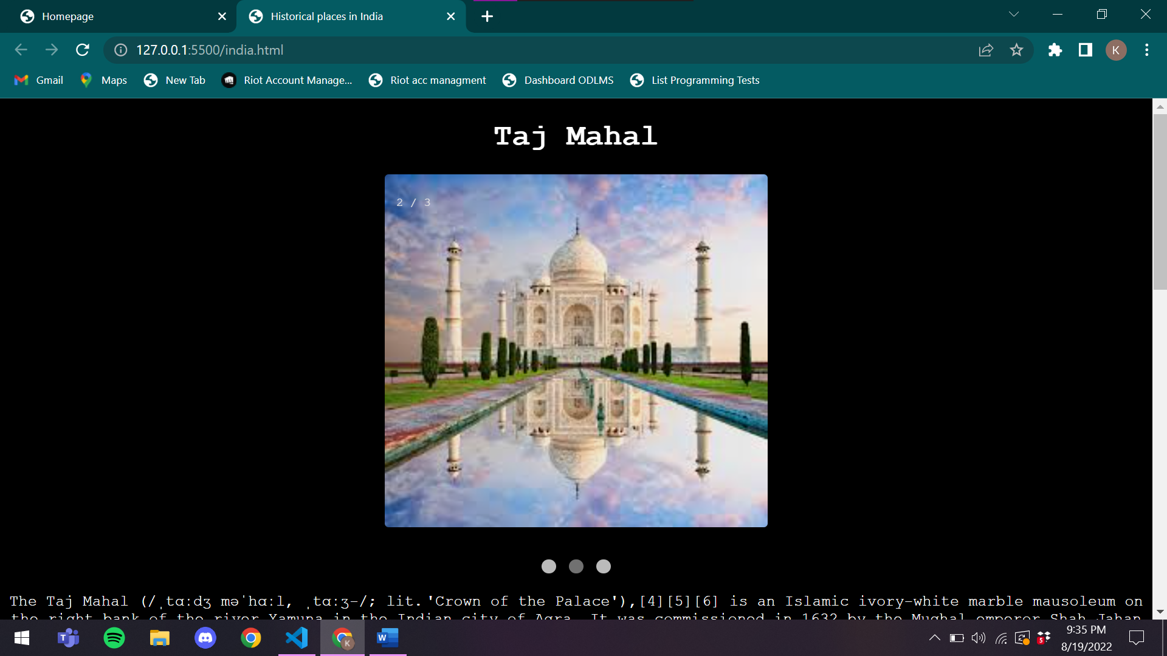

**Code:**

<!DOCTYPE html>

<html lang="en">

<head>

    <meta charset="UTF-8">

    <meta http-equiv="X-UA-Compatible" content="IE=edge">

    <meta name="viewport" content="width=device-width, initial-scale=1.0">

    <title>Historical places in India</title>

    <style>

        body{

            font-family: 'Courier New', Courier, monospace;

            text-align: center;

            color: white;

            background-color: black;

        }

        img{

            border-radius: 4px;

        }

        div{

            margin-top: 15px;

        }

        * {box-sizing: border-box;}

        .mySlides {display: none;}

        img {vertical-align: middle;}

        .slideshow-container {

            max-width: 400px;

            position: relative;

            margin: auto;

        }

        .text {

        color: #f2f2f2;

        font-size: 15px;

        padding: 8px 12px;

        position: absolute;

        bottom: 8px;

        width: 100%;

        text-align: center;

        }

        .numbertext {

        color: #f2f2f2;

        font-size: 12px;

        padding: 8px 12px;

        position: absolute;

        top: 0;

        }

        .dot {

        height: 15px;

        width: 15px;

        margin: 0 2px;

        background-color: #bbb;

        border-radius: 50%;

        display: inline-block;

        transition: background-color 0.6s ease;

        }

        .active {

        background-color: #717171;

        }

        .fade {

        animation-name: fade;

        animation-duration: 1.5s;

        }

        @keyframes fade {

        from {opacity: .4}

        to {opacity: 1}

        }

        @media only screen and (max-width: 300px) {

        .text {font-size: 11px}

        }

    </style>

</head>

<body>

    <h1>Taj Mahal</h1>

    <div class="slideshow-container">

        <div class="mySlides fade">

          <div class="numbertext">1 / 3</div>

          <img src="/india/ind1.jpeg" style="width:100%">

        </div>

        <div class="mySlides fade">

          <div class="numbertext">2 / 3</div>

          <img src="/india/ind2.jpeg" style="width:100%">

        </div>

        <div class="mySlides fade">

          <div class="numbertext">3 / 3</div>

          <img src="/india/ind3.jpeg" style="width:100%">

        </div>

        </div>

        <br>

        <div style="text-align:center">

          <span class="dot"></span>

          <span class="dot"></span>

          <span class="dot"></span>

        </div>

    <div>

        The Taj Mahal (/ˌtɑːdʒ məˈhɑːl, ˌtɑːʒ-/; lit. 'Crown of the Palace'),[4][5][6] is an Islamic ivory-white marble mausoleum on the right bank of the river Yamuna in the Indian city of Agra. It was commissioned in 1632 by the Mughal emperor Shah Jahan (r. 1628–1658) to house the tomb of his favourite wife, Mumtaz Mahal; it also houses the tomb of Shah Jahan himself. The tomb is the centrepiece of a 17-hectare (42-acre) complex, which includes a mosque and a guest house, and is set in formal gardens bounded on three sides by a crenellated wall.

        Construction of the mausoleum was essentially completed in 1643, but work continued on other phases of the project for another 10 years. The Taj Mahal complex is believed to have been completed in its entirety in 1653 at a cost estimated at the time to be around ₹32 million, which in 2020 would be approximately ₹70 billion (about US $1 billion). The construction project employed some 20,000 artisans under the guidance of a board of architects led by the court architect to the emperor, Ustad Ahmad Lahauri. Various types of symbolism have been employed in the Taj to reflect natural beauty and divinity.

        The Taj Mahal was designated as a UNESCO World Heritage Site in 1983 for being "the jewel of Muslim art in India and one of the universally admired masterpieces of the world's heritage". It is regarded by many as the best example of Mughal architecture and a symbol of India's rich history. The Taj Mahal attracts more than 6 million visitors a year[3] and in 2007, it was declared a winner of the New 7 Wonders of the World (2000–2007) initiative.

    </div>

    <h2>History</h2>

    <div>

        The Taj Mahal was commissioned by Shah Jahan in 1631, to be built in the memory of his wife Mumtaz Mahal, who died on 17 June that year, while giving birth to their 14th child, Gauhara Begum.[12][13] Construction started in 1632,[14] and the mausoleum was completed in 1648, while the surrounding buildings and garden were finished five years later.[15] The imperial court documenting Shah Jahan's grief after the death of Mumtaz Mahal illustrates the love story held as the inspiration for the Taj Mahal.

    </div>

    <h1>Red Fort</h1>

    <div class="slideshow-container">

        <div class="mySlides fade">

          <div class="numbertext">1 / 3</div>

          <img src="/india/ind4.jpeg" style="width:100%">

        </div>

        <div class="mySlides fade">

          <div class="numbertext">2 / 3</div>

          <img src="/india/ind5.jpeg" style="width:100%">

        </div>

        <div class="mySlides fade">

          <div class="numbertext">3 / 3</div>

          <img src="/india/ind6.jpeg" style="width:100%">

        </div>

        </div>

        <br>

        <div style="text-align:center">

          <span class="dot"></span>

          <span class="dot"></span>

          <span class="dot"></span>

        </div>

    <div>

        The Red Fort or Lal Qila (Hindustani: [laːlqiːlaː]) is a historic fort in Old Delhi, Delhi in India that served as the main residence of the Mughal Emperors. Emperor Shah Jahan commissioned construction of the Red Fort on 12 May 1638, when he decided to shift his capital from Agra to Delhi. Originally red and white, its design is credited to architect Ustad Ahmad Lahori, who also constructed the Taj Mahal. The fort represents the peak in Mughal architecture under Shah Jahan, and combines Persianate palace architecture with Indian traditions.

        The fort was plundered of its artwork and jewels during Nadir Shah's invasion of the Mughal Empire in 1739. Most of the fort's marble structures were subsequently demolished by the British following the Indian Rebellion of 1857. The fort's defensive walls were largely undamaged, and the fortress was subsequently used as a garrison.

        On 15 August 1947, the first Prime Minister of India, Jawaharlal Nehru, raised the Indian flag above the Lahori Gate. Every year on India's Independence Day (15 August), the Prime Minister hoists the Indian tricolour flag at the fort's main gate and delivers a nationally broadcast speech from its ramparts.

        The Red Fort was designated a UNESCO World Heritage Site in 2007 as part of the Red Fort Complex.

    </div>

    <h2>History</h2>

    <div>

        Emperor Shah Jahan commissioned construction of the Red Fort on 12 May 1638, when he decided to shift his capital from Agra to Delhi. Originally red and white, Shah Jahan's favourite colours,[7] its design is credited to architect Ustad Ahmad Lahori, who also constructed the Taj Mahal.[8][9] The fort lies along the Yamuna River, which fed the moats surrounding most of the walls.[10] Construction began in the sacred Islamic month of Muharram, on 13 May 1638.[11]: 01  Supervised by Shah Jahan, it was completed on 6 April 1648.[12][13][14] Unlike other Mughal forts, the Red Fort's boundary walls are asymmetrical to contain the older Salimgarh Fort.[11]: 04  The fortress-palace was a focal point of the city of Shahjahanabad, which is present-day Old Delhi. Shah Jahan's successor, Aurangzeb, added the Moti Masjid (Pearl Mosque) to the emperor's private quarters, constructing barbicans in front of the two main gates to make the entrance to the palace more circuitous.

    </div>

    <script>

        let slideIndex = 0;

        showSlides();

        function showSlides() {

          let i;

          let slides = document.getElementsByClassName("mySlides");

          let dots = document.getElementsByClassName("dot");

          for (i = 0; i < slides.length; i++) {

            slides[i].style.display = "none";

          }

          slideIndex++;

          if (slideIndex > slides.length) {slideIndex = 1}

          for (i = 0; i < dots.length; i++) {

            dots[i].className = dots[i].className.replace(" active", "");

          }

          slides[slideIndex-1].style.display = "block";

          dots[slideIndex-1].className += " active";

          setTimeout(showSlides, 2000); // Change image every 2 seconds

        }

    </script>

</body>

</html>